Introduction
Concrete roads are a part of modern society. From the complex interstate highway system to a simple sidewalk that we use to walk down the street safely, they all can suffer the same fate when the seasons change: potholes. Potholes are both a huge safety issue and a destroyer of personal property. They are caused by water getting into the pores of the concrete and frigid temperatures freezing the water creating internal pressure in the concrete causing it to crack. When the concrete thaws it expands thus widening the cracks and creating potholes. Salt affects this process by lowering the freezing point of water. While this sounds like a good thing, doing so allows water to seep deep down into the pores of the concrete and if the salt water freezes, it expands; this creates even more pressure in the concrete and speeds the process of pothole creation. Potholes cause damage to vehicles on a yearly basis, the amount of damage is substantial. From bent wheels to broken axles and suspension parts, hitting a pothole could lead to thousands of dollars in repair bills or, depending on the car, the possibility of it being deemed totaled. As for the damage they can do directly to humans, they can cause unsuspecting victims to step right into them, causing them to fall leading to possible ankle, leg, or head injuries.
Salt seems to be a very bad method of melting ice but unfortunately it is currently the cheapest which is why it is so popular. Not melting this ice would result in an even more unsafe condition during the winter, so why pick between two poisons? That is where the idea behind this project came about. To develop a way to, rather than chemically remove the ice on the roads, remove it by heating up the road itself. The idea behind using water as a means of transferring heat came up by researching geothermal energy, an idea that was suggested by Professor James Ryan, from Macomb Community College. Geothermal energy is captured by pumping water through a network of pipes underneath the surface of the earth, capturing earth’s natural heat; this captured heat is then brought to the surface and used for various applications, such as heating homes and providing a source of hot water.
The experiment used water at three different temperatures running through a network of copper pipes that was placed into the concrete just after it was mixed so the concrete could set around the pipe. Then, water was run through the pipes at 3 different temperatures. The core and surface temperatures of the concrete were recorded throughout the experiment and the rate at which the concrete heated up was calculated.
While this was not conducted at the frigid cold temperatures of winter, the principles still apply. By using hot water to heat up concrete, the ice on the surface of the road would melt away and never freeze, leaving behind no salt residue and no harm to the road, thus keeping our roads safer and in a better condition than using conventional salt to melt the ice on the roads.

Review of Literature
One of the largest problems during the winter season in northern areas is that the roads tend to get very icy. One of the current solutions to this problem is applying rock salt to icy areas. Rock salt is able to melt the ice because it has a lower melting point than ice. Ice has a melting point of 0° Celsius. A 20 percent salt solution would have a melting point as low as -16° Celsius. Salt is also soluble in water, which means that it will dissolve in water. Because of this, when rock salt is applied to icy roads, the salt dissolves in the liquid water on the ice, and its lower melting point warms up the water, therefore melting the ice (“Why Do They Use Salt to Melt Ice on the Road in the Winter?").
While rock salt seems like a useful tool to melt ice, it has a lot of negative effects on the concrete itself. Concrete is a very porous material, even though it may look completely solid. When ice is present on the road, it is also solid, leaving the concrete unaffected. However, when rock salt is applied to the ice, the ice will melt, and the water will be absorbed by the concrete (“Concrete Damage From Rock Salt”). Rock salt is also hygroscopic, meaning that it can attract water and moisture from the surrounding environment. This means that when rock salt dissolves in water, it attracts more water molecules, and that solution, which has about 10 percent more water than it normally would, is absorbed by the concrete. This can cause large problems when the temperature drops below -4° Celsius because the extra water in the solution will freeze again and expand into the concrete, which adds hydraulic pressure to the concrete (“Concrete Damage From Rock Salt”).
Damage to concrete will occur when the hydraulic pressure of the ice exceeds the compression strength of the concrete. A one-time application of rock salt on concrete would not do much damage, but the more the water freezes and thaws, the more prone the concrete is to break apart, so using rock salt frequently will eventually damage concrete. This is how many potholes are formed in the road, because rock salt is used quite frequently on roads when they are icy (“Concrete Damage From Rock Salt”).
A study out of the Iowa State University tested various salts on icy roads to test their rate of deterioration. It was found that while rock salt was the least damaging in the short term, all of the salts put on the roads had adverse effects on the strength and durability of the concrete. The experiments placed the salts on in a wet/dry scenario, a freeze/thaw scenario, and a continuous soak situation. They also tested very high strength concrete and very low strength concrete. This experiment shows why a change needs to be made in the way ice is removed from roads because all the salts tested deteriorated the concrete in some way, shape, or form (Cody).
A change in heat is defined as the transfer of energy from a high temperature object to a low temperature object. In other words, a low temperature object cannot simply create its own heat; however, it can obtain it when a high temperature object is in its presence (Nave). Because of this, it is reasonable to suggest that the hotter the high temperature object is, the faster the energy will be transferred to the low temperature object. This is due to the fact that when molecules are heated up, they have more energy and they move faster. This supports the hypothesis that higher temperatures of water will yield a higher rate of change in temperature of the concrete that the water runs through.
There are many alternatives to rock salt that can be used to melt ice on the road. One such alternative is the use of a heating element. One of the most common heating elements is the electric heating element. Most electric heating elements are made of nichrome, a non-magnetic alloy that consists of about 80 percent nickel and 20 percent chrome. Nichrome is used mainly for its high melting point of 1400° Celsius. Also, nichrome is often coated in ceramic, a substance that can withstand many heating and cooling cycles. Heating elements like this are often found in many household devices, such as stoves, toasters, and water heaters (Woodford).
While it may seem dangerous to use an electric heating element under the roads as it seems like a fire hazard, concrete is actually very fire resistant. Concrete is made of materials like limestone, clay, and gypsum. All of these materials are impervious to combustion because they have little to no ability to react at all. In other words, it is physically safe to use heating elements to heat concrete because it will not catch on fire as it is practically non-combustible (Cancio).
Because concrete is fire resistant, it also has a slower rate of heat transfer. For example, if a fire starts on one side of the concrete, the other side of the concrete will take a long time to heat up because concrete is a poor conductor for heat energy. In order for heat to travel through the concrete, the heating element used would have to be heated to a higher temperature. This would excite the molecules in the concrete, and in a chain reaction would allow heat to flow from one side to the other (Cancio). So, even though ice only needs to be heated above 0° Celsius in order to melt, the concrete needs to be accounted for, and a higher temperature must come from the heating element. Originally, the experiment called for using a lower temperature that would still melt the ice, but this would not work due to the concrete’s fire resistant properties.
Another much more energy efficient way to heat the underside of the roads would be to use geothermal energy. Geothermal energy uses the earth’s natural heat from the liquid layer of magma underneath the crust and uses that to heat water. Starting at about 5 feet underground, the earth stays at a constant 50° Fahrenheit. By pumping this water up and over an evaporator, the gas in the evaporator begins to rise towards the compressor. The compressor compresses and heats this gas that is sent to the condenser. The condenser transfers this heat to a separate water system which is used to provide heat to a building. This could be transferred to the road by pumping this hot water through pipes underneath the road and allowing the heat to radiate out of the pipes and into the road. (How A Ground Source Heat Pump Works (HD)).
The specific heat of a substance is the amount of heat energy per unit of mass needed to raise the temperature of the substance by one degree Celsius (Nave). Every object has its own specific heat because the transfer of energy may be faster or slower, depending on the given material. Concrete has a specific heat of 0.96 J/g°C. This means that it takes 0.96 Joules of heat energy for every gram of concrete to raise the temperature of the concrete by one degree Celsius (“Solids – Specific Heats”). This specific heat, when compared to that of water, which has a specific heat of 4.184 J/g°C, is very low. This explains why geothermal energy can be used to heat something like concrete: it does not take a lot of heat energy to raise its temperature, especially when the initial temperature of the concrete is low, as it would be in the winter.
Another application of geothermal energy and/or the use of heating elements as an alternative to rock salt are for driveways. Driveways in snowy weather are another source of anger for people in the winter months. Main roads in busy cities are usually plowed, leaving the side streets and driveways full of snow. This is where a heated driveway could help in removing the snow. Using either geothermal energy or heating elements, driveways could be heated, eliminating the countless hours dedicated to shoveling snow (Pickett).
There are many alternatives to salt that need to be explored to see their effectiveness against standard rock salt. They show good potential to remove the adverse effect road salt can have on our roads and our environment. They also show potential for being able to revolutionize the safety of roads by heating up the roads before ice can even form, thus keeping the roads safer in the winter months.

Problem Statement
Problem:
What is the rate of change of the core temperature and the surface temperature of concrete when heated from beneath using hot water lines?
Hypothesis:
The hottest water temperature will yield the largest rate of change of the concrete core and surface temperatures.
Data Measured:
The independent variables are the three different water temperatures; these temperatures are 30° C, 50° C, and 70° C. The dependent variables are the core and surface temperatures of the concrete. During the experiment the treatment of hot water will be applied to the concrete for 300 seconds. The surface and core temperatures will be recorded at the beginning and the end of the experiment. The change in temperature will be recorded and then a rate will be calculated by dividing it by the length of the trial. Four two-sample t-tests will be done to compare the rates of change in temperature between the 30° and 50° water trials, and the 50° and 70° water trials, at the core and the surface of the concrete.

Experimental Design
Materials:

Cement Block
High temperature water pump
Vernier LabQuest
(2) Vernier LabQuest temperature probes
Hot plate
Sauce pan
Water
Thermometer
TI-Nspire calculator
(2) 2.5 ft lengths of ¾ in rubber hose
2 ft length of ¾ in rubber hose
Masking tape
Electric water pump
12DC power supply
Mason jar
Funnel
Laptop

Procedure:
1. Using the TI-Nspire random integer function, randomize trials for the experiment. 10 trials will be conducted for each water temperature.

2. Construct the cement block with copper piping (Appendices A and B).
3. Connect one 2.5 ft length of rubber hose to the inlet of the pump and place it into the sauce pan.

4. Connect the 2 ft length of rubber hose to the pump outlet and to one side of the copper pipe in the cement block.

5. Connect the last 2.5 ft length of rubber hose to the other copper pipe in the cement block and place into sauce pan.

6. Fill sauce pan with water, place sauce pan onto hot plate.
7. Connect pump to power supply.
8. Place temperature probes in the holes drilled in concrete block for the core and surface temperatures.

9. Connect temperature probes to LabQuest.
10. Connect LabQuest to the laptop.
11. Set trial time to 300 seconds.
12. Use masking tape to attach thermometer to outlet hose in the sauce pan, making sure the end is in the water.
13. Heat water to set temperature according to the trial, check water temperature using thermometer.

14. Take inlet hose out of sauce pan and place funnel into it, then use the Mason jar to introduce heated water into the system.

15. Place inlet hose into the sauce pan and wait until system is purged of air.
16. Once system is purged of air, begin data collection.
17. After trial, remove hoses from the concrete and dump out the water.
Diagrams:
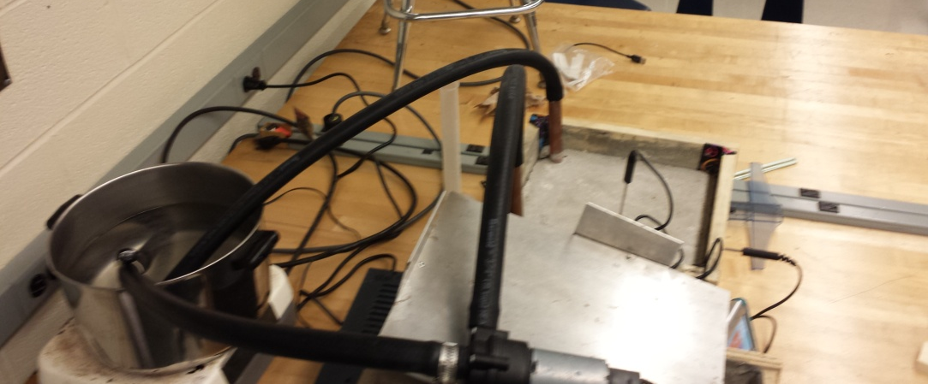
Pump outlet hose/
concrete inlet hose
Pump inlet hose
Concrete outlet hose
Figure 1. Plumbing setup
Figure 1 shows the setup of the rubber tubing and how it flows from the sauce pan to the pump, through the cement and back into the sauce pan.

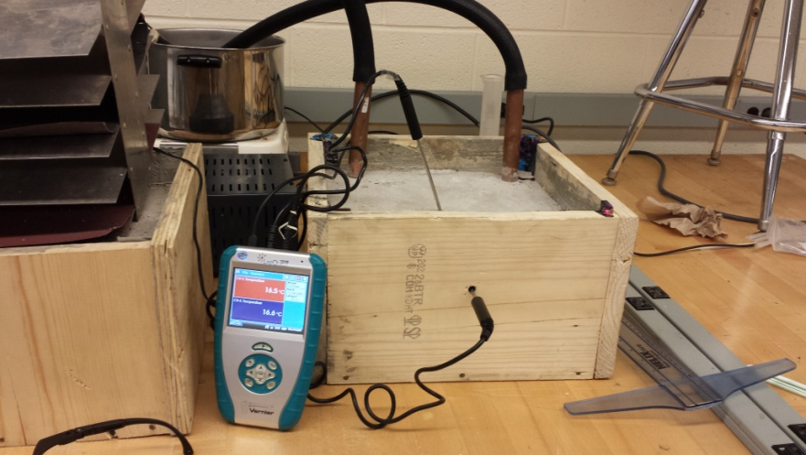
Surface temperature probe
Core temperature probe
Figure 2. LabQuest setup
Figure 2 shows the LabQuest and the placement of the temperature probes in the block of cement.
Data and Observations
Table 1
Trial Results
Trial Number | Trial Water Temp (°C) | Recorded Water Temp (°C) | ΔTemp Core (°C) | ΔTemp Surface (°C) | Rate Core (°C/sec) | Rate Surface (°C/sec)
1 | 50 | 48.8 | 2.5 | 0.9 | 0.0083 | 0.0030
2 | 30 | 31.7 | 1.0 | 0.6 | 0.0033 | 0.0020
3 | 30 | 29.8 | 0.7 | 0.6 | 0.0023 | 0.0020
4 | 30 | 30.5 | 1.1 | 0.6 | 0.0037 | 0.0020
5 | 50 | 51.0 | 1.7 | 1.3 | 0.0057 | 0.0043
6 | 70 | 71.0 | 2.1 | 1.4 | 0.0070 | 0.0047
7 | 30 | 30.2 | 0.6 | 0.6 | 0.0020 | 0.0020
8 | 30 | 33.0 | 0.7 | 0.6 | 0.0023 | 0.0020
9 | 50 | 49.6 | 2.5 | 0.3 | 0.0083 | 0.0010
10 | 70 | 68.2 | 3.0 | 1.5 | 0.0100 | 0.0050
11 | 30 | 31.2 | 0.6 | 0.4 | 0.0020 | 0.0013
12 | 50 | 52.3 | 2.6 | 1.4 | 0.0087 | 0.0047
13 | 30 | 31.3 | 1.2 | 0.4 | 0.0040 | 0.0013
14 | 70 | 69.7 | 2.6 | 1.1 | 0.0087 | 0.0037
15 | 50 | 48.6 | 1.5 | 1.0 | 0.0050 | 0.0033
16 | 30 | 32.1 | 1.0 | 0.2 | 0.0033 | 0.0007
17 | 50 | 50.9 | 2.0 | 1.3 | 0.0067 | 0.0043
18 | 50 | 50.2 | 1.7 | 0.8 | 0.0057 | 0.0027
19 | 70 | 67.0 | 2.0 | 0.7 | 0.0067 | 0.0023
20 | 70 | 68.0 | 2.4 | 1.4 | 0.0080 | 0.0047
21 | 30 | 32.1 | 0.9 | 0.5 | 0.0030 | 0.0017
22 | 70 | 70.0 | 2.3 | 0.9 | 0.0077 | 0.0030
23 | 70 | 72.6 | 2.0 | 1.3 | 0.0067 | 0.0043
24 | 70 | 73.7 | 1.8 | 1.4 | 0.0060 | 0.0047
25 | 30 | 29.6 | 0.7 | 0.6 | 0.0023 | 0.0020
26 | 50 | 48.0 | 1.5 | 0.4 | 0.0050 | 0.0013
27 | 70 | 66.8 | 2.8 | 0.7 | 0.0093 | 0.0023
28 | 70 | 69.4 | 2.3 | 1.5 | 0.0077 | 0.0050
29 | 50 | 52.7 | 2.0 | 0.5 | 0.0067 | 0.0017
30 | 50 | 52.0 | 2.4 | 0.9 | 0.0080 | 0.0030

Table 1 shows all of the results of the experiment. 30 trials were conducted, there were three possible temperatures at which the water could be so that a trial could be conducted and there were 10 trials per water temperature. Going from left to right the columns are as follows: trial number, set trial water temperature, recorded trial water temperature, change in core temperature, change in surface temperature, rate of change of core temperature, and rate of change of surface temperature. The set water temperature value and the true temperature of each trial were recorded because due to equipment limitations it was nearly impossible to get the water temperature stable at a set 30, 50 or 70 degrees Celsius. The temperatures vary by a maximum of ± 4 degrees Celsius.
The following equation was used to calculate the change in temperature:
$$Core End Temperaure \left(°C\right)-Core Start Temperaure \left(°C\right)=Change in Core Temperature(°C)$$
Figure 3. Delta Temperature Equation
Figure 3 shows the equation used to calculate the change in core temperature. All of the data seen in Table 1 was derived data from temperature probes. The same equation was used to calculate the change in surface temperature only using the temperatures for surface.
The following equation was used to find the rate of change in temperature:
$$\frac{Change in Core Temperature(°C)}{300 (seconds)}=Rate of Change of Core Temp(\frac{°C}{second})$$
Figure 4. Rate of change of temperature over time
Figure 4 showed the equation used to calculate the rate at which the core temperature changed. This equation works by taking the change in the core temperature and dividing it by the length of the trial in seconds to get the rate of change of the core temperature in seconds. (Appendix C)

Table 2
Trial Observations
Trial Number | Observations
1 | Delta value for surface temperature seemed slightly lower than expected. Observed that this was due to the cold pipes absorbing much of the heat not allowing it to hit the concrete.
2 | Outside door opened during trial causing drop in air temperature which may have affected surface temperature, caused slight drop in temperature in the middle of data collection which was soon corrected as the trial went on after the door was shut again.
6 | Power lost to pump halfway through trials, was quickly corrected but pump was down for approximately 10 seconds during data collection.
7 | Slightly lower delta core temperature, possibly caused by block core temperature approaching 30 degrees Celsius.
8 | Block was allowed to cool slightly before the final trial was conducted. Did not yield any significant changes in delta temperatures.
9 | Outside door opened during trial causing drop in air temperature which may have affected surface temperature, caused slight drop in temperature in the middle of data collection which was soon corrected as the trial went on after the door was shut again.
10 | Very high spike in temperatures. Possibly due to spike in air temperature.
11 | Delta value for surface slightly lower due to it being the first trial of that day.
13 | Outside door opened during trial causing drop in air temperature which may have affected surface temperature, caused slight drop in temperature in the middle of data collection which was soon corrected as the trial went on after the door was shut again.
14 | Air temperature in room returned to normal, did not seem to affect data significantly.
16 | Delta value for surface slightly lower due to it being the first trial of that day.
17 | Results seemed to begin as normal as pipes were warmed up.
19 | Outside door opened during trial causing drop in air temperature which may have affected surface temperature, caused slight drop in temperature in the middle of data collection which was soon corrected as the trial went on after the door was shut again.
20 | Air temperature in room returned to normal, may have led to spike in temperatures
21 | Delta value for surface slightly lower due to it being the first trial of that day.
26 | Delta value for surface slightly lower due to it being the first trial of that day.
27 | Low delta surface value.
28 | Results seemed to begin as normal as pipes were warmed up.
29 | Surface temperatures affected by outside door being opened.
30 | Surface temperatures affected by outside door being opened.

Table 2 shows the observations taken during trials. It is important to note that the first trials of the day always seemed to have slightly lower surface temperatures. Surface temperatures were also greatly affected by the air temperature of the room and any fluctuation during trials did seem to cause a slight drop in surface temperatures. Due to the drop in air temperature in the room often times the heat would kick on causing the air temperature to rise thus causing the surface temperature to spike in the other direction before settling back down again once the air temperature of the room returned back to normal.
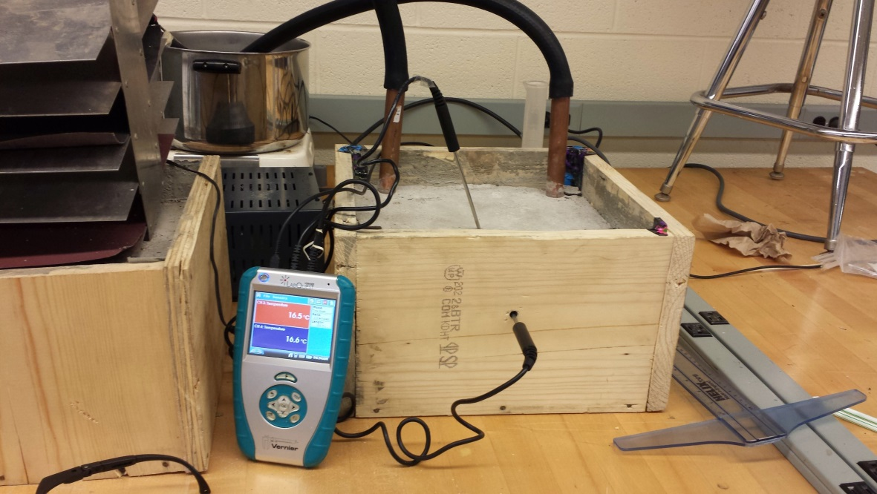
Surface temperature probe
Core temperature probe
Figure 5. LabQuest and Temperature Probes
Figure 5 shows the LabQuest with the temperature probed connected and in their locations in the block. The core temperature sensor is the probe that is located in the hole drilled through the side of the concrete block. The surface temperature probe is in the slight crevice drilled out in the top of the block.
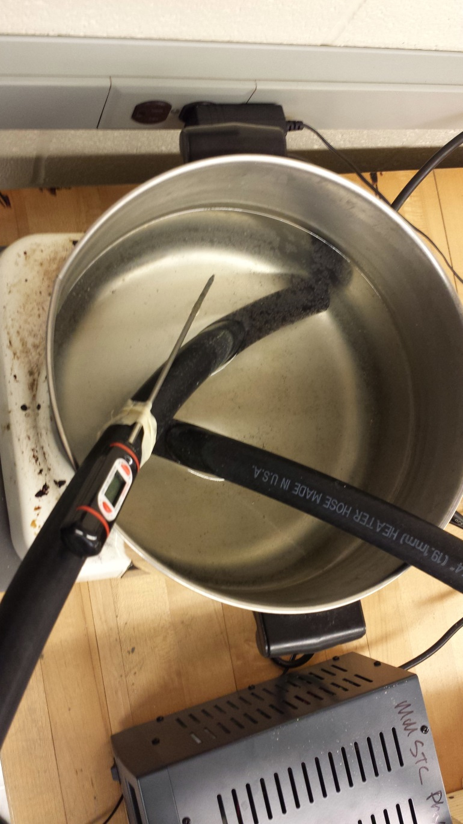
Water thermometer
Figure 6. Water Thermometer
Figure 6 shows the thermometer placed in the water which was used to measure temperature, this item was crucial in running the trials because the water had to be within a certain range for the trial to be run and get correct data.

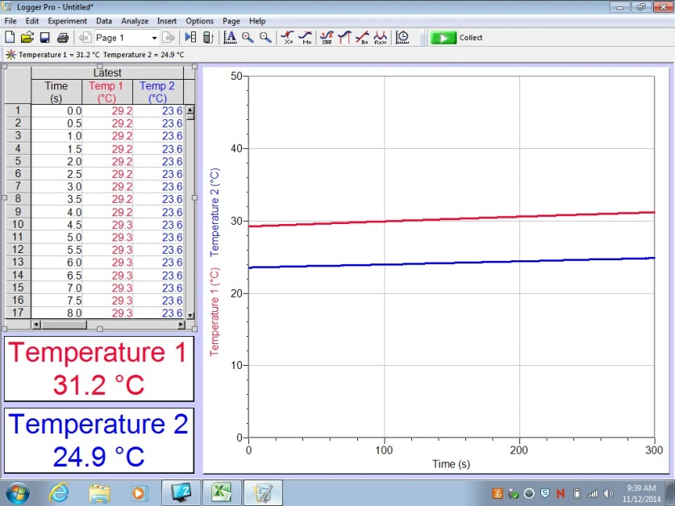
Figure 7. Sample data graph
Figure 7 shows a sample data graph. In this trial, 50º Celsius water was run through the pipes in the concrete. The graph shows the lines that represent the increase in temperature of the concrete at the core (red) and at the surface (blue). The two temperatures shown are the final temperatures of the concrete, while the initial temperatures can be seen in the table after zero seconds of data collection.

Data Analysis and Interpretation
The quantitative data was collected in a controlled environment such that any outside factors that could have affected the data were minimal. If there were more outside factors affecting the data, then the data would not be reliable as it would not simulate what happens when the experiment is applied to the real world. The only factor that was noted was that there were slight fluctuations in room temperature that could have affected the data for some trials that measured the temperature at the surface of the concrete. The trials were randomized to reduce bias and to ensure that each trial had an equal chance of being chosen. The trials were also replicated to ensure little variability between them.
0.002833
0.0068
Mean = 0.002833
Mean = 0.007767
Mean = 0.0068
Figure 8. Boxplots of Core Temperature Changes
Figure 8 shows the boxplots of the change in temperature of the core of the concrete, for all three treatment groups, which were 30°, 50°, and 70° water. The mean lines are also shown, which in the case of these boxplots, all three means are above the median. The 30° water shows little variability at all compared to the other two samples. This indicates that all of the data in that sample is fairly similar, whereas in the other two, it is more spread out. The 30° sample is also slightly skewed to the right, whereas the other two show fairly normal distributions. This indicates that the data is a fairly good representation of the actual rate of change in temperature of concrete when water at the given temperatures is run through it. Also, the 30° boxplot does not overlap the other two at all, which is a very strong indicator that there is a statistically significant difference between them. As for the 50° and 70° samples, there is a lot of overlap, but the medians and means between the two are very different. The median of the 50° boxplot does not overlap the box for the 70° boxplot, which indicates that there may be a difference between the two. There are no outliers in any of the data sets.
70
0.002933
Mean = 0.003967
Mean = 0.002933
Mean = 0.002833
Figure 9. Boxplots of Surface Temperature Changes
Figure 9 shows the boxplots of the change in temperature of the surface of the concrete, for all three treatment groups, which were 30°, 50°, and 70° water. The 30° boxplot shows that the median is equal to the third quartile, which indicates that the data is skewed to the left. However, the remaining portions of the boxplot are fairly well spread out. This means that many of the data points were equal to 0.002 °C/sec, but the rest of the values, when by themselves, would give the data a normal distribution. As for the other two boxplots, the 50° boxplot shows a normal distribution, and the 70° boxplot is skewed to the left. The skew is caused by many of the data points having a similar value to the median, the third quartile, and the maximum. There is some overlap between the 30° and 50° boxplots and the 50° and 70° boxplots. However, their medians and means are all very different from each other, indicating a possibility that there is a statistically significant difference between all of them. There are no outliers in any of the data sets.
Four two-sample t-tests were carried out to see if there is a statistically significant difference between all of the treatments, for both the core and the surface of the concrete. The two-sample t-test is the correct statistical test to do because two sample means from two independent populations are being compared to each other. A 95% confidence interval was also calculated for each statistical test. This tells us the average difference of means between the two tested samples, with 95% confidence.
In order to carry out the statistical tests, some assumptions must be met. All assumptions for each of the tests will be listed, because all of the tests have very similar data. The first assumption is that each group is a simple random sample, which is met for all four tests. The second assumption is that the two given groups are independent of each other. This assumption is met for all four tests because the experiment was controlled in such a way that the data collected from one treatment group did not affect the data collected from the other treatment group. The last assumption is that the distributions of all of the samples are normal. Because each sample consisted of ten trials, normality cannot be assumed, and it must be checked.
To check the normality of the data sets, normal probability plots were made for each data set.

Figure 10. Normal Probability Plot (30° Core Treatment)
Figure 10 shows the normal probability plot for the 30° water treatment, measured at the core of the concrete. The expected z values for ten data points were found using the normal probability plot function on the TI-Nspire calculator. The line given is the line of best fit for the given data, and the R² value given on the graph is the correlation coefficient squared. The correlation coefficient for this set of data is 0.9558. This indicates a good linear fit, which in turn specifies that the data is fairly normal.

Figure 11. Normal Probability Plot (30° Surface Treatment)
Figure 11 shows the normal probability plot for the 30° water treatment, measured at the surface of the concrete. The expected z values for ten data points were found using the normal probability plot function on the TI-Nspire calculator. The line given is the line of best fit for the given data, and the R² value given on the graph is the correlation coefficient squared. The correlation coefficient for this set of data is 0.9654. This indicates a good linear fit, which in turn specifies that the data is fairly normal.

Figure 12. Normal Probability Plot (50° Core Treatment)
Figure 12 shows the normal probability plot for the 50° water treatment, measured at the core of the concrete. The expected z values for ten data points were found using the normal probability plot function on the TI-Nspire calculator. The line given is the line of best fit for the given data, and the R² value given on the graph is the correlation coefficient squared. The correlation coefficient for this set of data is 0.9495. This indicates a good linear fit, which in turn specifies that the data is fairly normal.

Figure 13. Normal Probability Plot (50° Surface Treatment)
Figure 13 shows the normal probability plot for the 50° water treatment, measured at the surface of the concrete. The expected z values for ten data points were found using the normal probability plot function on the TI-Nspire calculator. The line given is the line of best fit for the given data, and the R² value given on the graph is the correlation coefficient squared. The correlation coefficient for this set of data is 0.9724. This indicates a good linear fit, which in turn specifies that the data is fairly normal.

Figure 14. Normal Probability Plot (70° Core Treatment)
Figure 14 shows the normal probability plot for the 70° water treatment, measured at the core of the concrete. The expected z values for ten data points were found using the normal probability plot function on the TI-Nspire calculator. The line given is the line of best fit for the given data, and the R² value given on the graph is the correlation coefficient squared. The correlation coefficient for this set of data is 0.9822. This indicates a good linear fit, which in turn specifies that the data is fairly normal.

Figure 15. Normal Probability Plot (70° Surface Treatment)
Figure 15 shows the normal probability plot for the 70° water treatment, measured at the surface of the concrete. The expected z values for ten data points were found using the normal probability plot function on the TI-Nspire calculator. The line given is the line of best fit for the given data, and the R² value given on the graph is the correlation coefficient squared. The correlation coefficient for this set of data is 0.923. This indicates a good linear fit, which in turn specifies that the data is fairly normal.
Now that normality has been checked, the statistical tests can be carried out. For a sample calculation of the two-sample t-test and a 95% confidence interval, refer to Appendix D. The null and alternative hypotheses for the first test, which will compare the means of the 30° water trials and the 50° water trials, with the temperature recorded in the core of the concrete, are as follows:

$$H_{o}:μ_{30}=μ_{50}$$
$$H_{a}:μ_{30}<μ_{50}$$
The null hypothesis states that the means for both populations are equal, and the alternative hypothesis states that the mean rate of change in temperature for the 30° water trials is less than the mean rate of change in temperature for the 50° water trials. The t value for the statistical test is -7.7737, which yields a P-value of 0. The null hypothesis is therefore rejected at the α level of 0.05, giving significant evidence that when 30° water runs through concrete, the rate of change in temperature of the concrete will be slower than that of when 50° water runs through concrete. This also means that there is a 0% chance of getting results this extreme by chance alone if the null hypothesis is true. A 95% confidence interval will tell us that the difference in means for the two populations is 0.00396, which indicates that, on average, the rate of change in temperature of the concrete when 30° water runs through it was 0.00396 °C/sec slower than that of when 50° water runs through it.
The null and alternative hypotheses for the second test, which will compare the means of the 50° water trials and the 70° water trials, with the temperature recorded in the core of the concrete, are as follows:
$$H_{o}:μ_{50}=μ_{70}$$
$$H_{a}:μ_{50}<μ_{70}$$
The null hypothesis states that the means for both populations are equal, and the alternative hypothesis states that the mean rate of change in temperature for the 50° water trials is less than the mean rate of change in temperature for the 70° water trials. The t value for the statistical test is -1.5924, which yields a P-value of 0.0645. We therefore fail to reject the null hypothesis at the α level of 0.05, giving no evidence that when 50° water runs through concrete, the rate of change in temperature of the concrete will be slower than that of when 70° water runs through concrete. This also means that there is a 6.45% chance of getting results this extreme by chance alone if the null hypothesis is true. A 95% confidence interval will tell us that the difference in means for the two populations is 0.00096, which indicates that, on average, the rate of change in temperature of the concrete when 50° water runs through it was 0.00096 °C/sec slower than that of when 70° water runs through it.
The null and alternative hypotheses for the third test, which will compare the means of the 30° water trials and the 50° water trials, with the temperature recorded at the surface of the concrete, are as follows:
$$H_{o}:μ_{30}=μ_{50}$$
$$H_{a}:μ_{30}<μ_{50}$$
The null hypothesis states that the means for both populations are equal, and the alternative hypothesis states that the mean rate of change in temperature for the 30° water trials is less than the mean rate of change in temperature for the 50° water trials. The t value for the statistical test is -2.5342, which yields a P-value of 0.0129. The null hypothesis is therefore rejected at the α level of 0.05, giving significant evidence that when 30° water runs through concrete, the rate of change in temperature of the surface of the concrete will be slower than that of when 50° water runs through concrete. This also means that there is a 1.29% chance of getting results this extreme by chance alone if the null hypothesis is true. A 95% confidence interval will tell us that the difference in means for the two populations is 0.00113, which indicates that, on average, the rate of change in temperature of the surface of concrete when 30° water runs through it was 0.00113 °C/sec slower than that of when 50° water runs through it.
The null and alternative hypotheses for the fourth test, which will compare the means of the 50° water trials and the 70° water trials, with the temperature recorded at the surface of the concrete, are as follows:
$$H_{o}:μ_{50}=μ_{70}$$
$$H_{a}:μ_{50}<μ_{70}$$
The null hypothesis states that the means for both populations are equal, and the alternative hypothesis states that the mean rate of change in temperature for the 50° water trials is less than the mean rate of change in temperature for the 70° water trials. The t value for the statistical test is -1.9541, which yields a P-value of 0.0335. The null hypothesis is therefore rejected at the α level of 0.05, giving significant evidence that when 50° water runs through concrete, the rate of change in temperature of the surface of the concrete will be slower than that of when 70° water runs through concrete. This also means that there is a 3.35% chance of getting results this extreme by chance alone if the null hypothesis is true. A 95% confidence interval will tell us that the difference in means for the two populations is 0.00103, which indicates that, on average, the rate of change in temperature of the surface of concrete when 50° water runs through it was 0.00103 °C/sec slower than that of when 70° water runs through it.
To summarize, the temperatures of the water that ran through the concrete did have significantly different effects on the concrete at both the core and surface, with the exception of the 50º and 70º water trials, at the core of the concrete. The p-value of this test was 0.0645, which is just large enough to fail to reject the null hypothesis that the means of the two samples are equal. The other p-values of 0, 0.0129, and 0.0335 were smaller than the alpha level of 0.05, and therefore rejected the null hypothesis, deeming them significantly different.

Conclusion
To conclude, the original hypothesis that as the temperature of the water that was flowing through the concrete increased, the rate of change in temperature of the concrete would also increase was accepted. At the core of the concrete, the 30° water trials gave an average rate of change in temperature to be 0.0028°C/sec. This can be compared to the 50° and 70° water trials, which yielded averages of 0.0068°C/sec and 0.0078°C/sec, respectively. These rates are noticeably faster than the 30° water trials. At the surface of the concrete, the 30° water trials gave an average rate of change in temperature to be 0.0018°C/sec. This can be compared to the 50° and 70° water trials, which yielded averages of 0.0029°C/sec and 0.0040°C/sec, respectively. These rates are noticeably faster than the 30° water trials.
The statistical tests showed that as the temperature of the water increased, the rate of change in temperature of the concrete also increased, at a statistically significant level for all but one of the statistical tests. The p-values for the three tests that showed a significant difference were 0, 0.0129, and 0.0335. At the alpha level of 0.05, these all rejected the null hypothesis that the means of the two given populations were equal. The only test that showed no significant difference was the test that compared the means of the 50º and 70º water trials, in the core of the concrete. This yielded a p-value of 0.0645, which is small enough to indicate that there was a difference, but it was not statistically significant.
The rate of change in temperature of the concrete, at both the core and the surface, increased as the temperature of the water running through it increased because the copper piping that was used was a good conductor of heat. When the pipes heated up, they gave off energy, which is transferred from hot particles to cold particles by means of conduction. The pathways in this system were the pores in the concrete. While it is true that the particles lose energy as they bounce off all of the walls inside the concrete, the hotter water gave off more energy, and the leftover energy after travelling through the concrete was therefore also stronger than that of when cooler water ran through the pipes.
The idea of stronger energy giving off more heat is basic. Geothermal energy, which is currently a popular way to heat homes in the winter, takes advantage of the scientific laws of energy. These laws can also be applied, through the same system of geothermal energy, to heat other objects, such as concrete. Rock salt is a common way to melt ice on the roads, but it causes potholes to form in the concrete when the water refreezes and expands. If the system of geothermal energy is used, it would continuously keep roads and sidewalks warm as to continuously melt the ice. This way, potholes are not formed, and roads are completely ice-free.
The major weaknesses of the experiment are associated with the temperature of the room that the block of concrete sat in. The temperature of the room was not held constant. Most of the time, the block sat in room temperature, but the temperature fluctuated when doors were opened. The temperature probes were exposed to the air, so when the room temperature dropped, the temperature probe picked up cooler temperatures and recorded them onto the graph. Due to time constraints, the net change in temperature for those trials was still recorded.
One weakness associated with the experimental setup was that the block of concrete was not exposed to temperatures that would simulate winter. While the initial temperature of the block does not affect the rate of change in temperature, there was never any ice frozen to the concrete for the hot water to melt. A procedure that records the time it takes to melt the ice using hot water versus rock salt could be carried out as further research. This could prove that using geothermal energy is more time efficient than using rock salt, and that it is safer to use as a system to melt ice because using rock salt can cause potholes. Potholes are caused by water refreezing and expanding after rock salt melts the ice, so further research could be conducted to see if geothermal energy could be used constantly throughout the winter so that the water would never refreeze. Using geothermal energy would revolutionize melting ice on roads in the winter. Water could be continuously run through the pipes so that ice would never be a problem, and potholes could possibly become less prominent.

Acknowledgements
We would like to give thanks to Mrs. Kim Gravel for all formatting and writing help, Mrs. Rose Cybulski for help with interpreting statistical tests, Mrs. Christine Tallman for checking all of the math and statistics done for the experiment, Mr. Greg McMillan for helping us throughout the experimental process, Mr. Mark Supal for helping us construct all of the needed materials for the experiment, and our families and friends for their support. We would also like to thank Mr. James Ryan, the robotics teacher at South Lake High School and the Engineering professor at Macomb Community College, for giving us the idea of simulating geothermal energy as a way to heat roads in the winter.

Appendix A: Concrete Block
Materials:

(2) 12 in x 6.5 in x 0.5 in wood boards
(2) 11 in x 6.5 in x 0.5 in wood boards
12 in x 12 in x 0.5 in wood board
Nails
Wood screws
Duct tape
¼ in masonry drill bit
40 lbs dry concrete mix
Trowel
Hammer
Drill
Water piping
Ruler
Pencil
Water

Procedure:
1. See Appendix B to construct water piping.
2. Attach the two 12 in x 6.5 in wooden boards to the 12 in x 12 in wooden base on opposing sides using nails.

3. Attach the two 11 in x 6.5 in wooden boards to the 12 in x 12 in wooden base on opposing sides using nails.

4. Use the drill to run screws into the wood to secure the wooden box together, running the screws in the base and the sides.

5. Use duct tape to seal up the edges of the wooden box to prevent the concrete from spilling.

6. Using a ruler, mark the side of the box 1 in from the top to act as a fill line.
7. Pour small amounts of dry concrete mix into the wooden mold.
8. Add water and mix with trowel.
9. Repeat steps 7 and 8 gradually until the fill line is reached and the recommended consistency is achieved according to the directions on the bag of concrete mix.

10. Place water piping into the concrete and push all the way to the bottom.
11. Let concrete set for 3 days.

12. Use a ¼ in masonry drill bit to drill a 6 in long hole through the side of the block for the temperature probe to measure core temperature
13. Using the ¼ in masonry drill bit drill a ¼ in long hole in the center of the top of the block for the temperature probe to measure surface temperature.

Diagram:
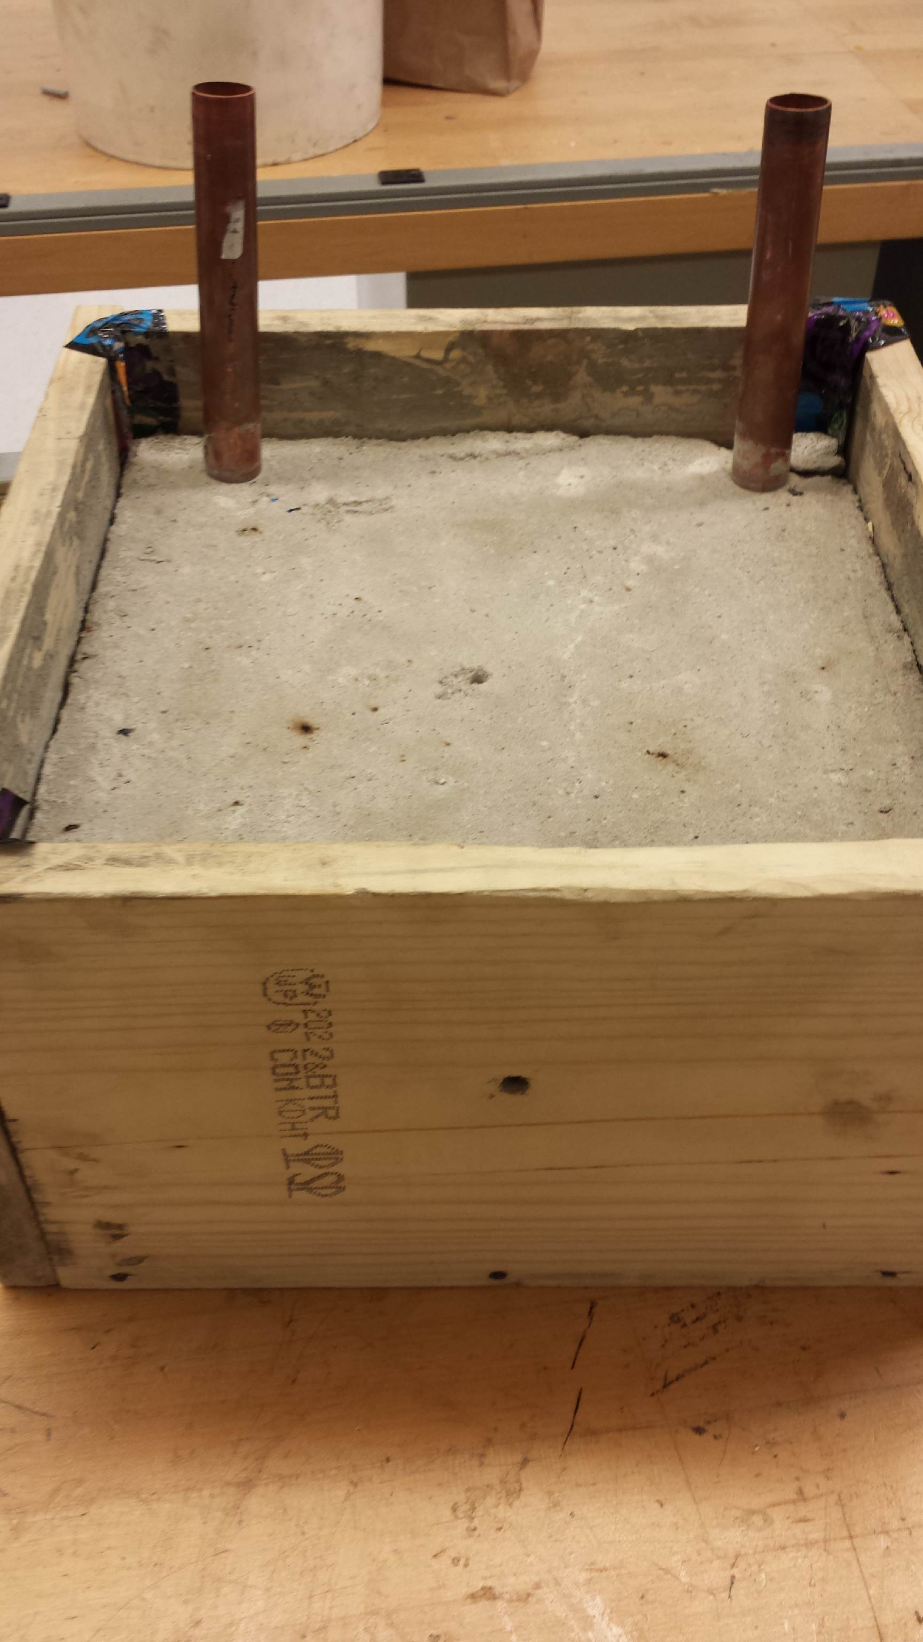
Copper piping
Core temp hole
Surface temp hole
Figure 16. Concrete block
Figure 16 shows the concrete block completed. The holes for the temperature probes are labeled as well as the water lines.

Appendix B: Water Piping
Materials:
(4) 8 in lengths of ¾ in copper piping
(3) 2 in lengths of ¾ in copper piping
(2) 11 in lengths of ¾ in copper piping
(8) ¾ in copper 90° elbows
200 grit sand paper
Flux
Solder
Propane Torch

Procedure:
1. Be sure the room in which the soldering is taking place is well ventilated and proper safety precautions to prepare the work area have been completed.
2. Use sand paper to sand each end of the pipes on the outside ½ in down from the ends of the pipe.
3. Sand the inside of the 90° elbows.
4. Paste small amount of flux to the ends of the 11 in long copper pipes.
5. Insert each pipe into one 90° elbow.
6. Turn on propane torch.
7. Hold the end of the pipe with the elbow attached in the flame for 30 seconds.
8. Solder one 90° elbow to each 11 in long copper pipe by touching the solder to the hot pipe, the solder should melt and be drawn into the joint.
9. Repeat steps 1 through 8 for the remainder of the process.
10. Solder one 8 in length of copper pipe into the other side of the elbows soldered onto the 11 in lengths.
11. Solder one 90° elbow onto each of the 8 in lengths of copper piping, aiming one end of the elbow left and one right, do not aim the elbow back up in the direction of the 11 in pipe and do not aim the elbow down away from the 11 in pipe.
12. Solder one 2 in section of pipe to the 90° elbows attached in step 4.
13. Solder one 90° elbow to each 2 in length of pipe attached in step 5.
14. Solder the remaining 8 in lengths of pipe to the 90° elbows attached in step 6.
15. Use the remaining 2 in length of pipe to attach the two halves together.

Diagram:
2in pipe
11in pipe
2in pipe
8in pipe
Figure 17. Copper tubing diagram
Figure 17 shows the copper tubing completely built with the pipe lengths labeled.

Appendix C: Sample Calculations
$$Temp_{f}-{Temp}_{i}=∆Temperature$$
$$39.1 \left(°C\right)-36.7 \left(°C\right)=2.4(°C)$$
Figure 18. Sample calculation for delta temperature
Figure 18 shows a sample calculation of how to find the delta temperature value for both core and surface temperature. This was the data from trial number 19, where the final temperature was 39.1° Celsius and the initial temperature was 36.7° Celsius, which yielded a delta temperature of 2.4° Celsius.
$$Rate of Change in Temp= \frac{∆Temperature}{Time}$$
$$\frac{2.4\left(°C\right)}{300 Seconds}=0.008 (\frac{°C}{Second})$$
Figure 19. Sample calculation for rate of change of temperature over time
Figure 19 shows a sample calculation of how to find the rate of temperature change over time for both core and surface temperature. The data was from trial number 19, where the delta temperature was 2.4° Celsius, and the time of the trial was 300 seconds, yielding a rate of 0.008°C/sec.

Appendix D: Statistical Sample Calculations
The following formula was used to calculate the t-statistic for the data:
$$t= \frac{(\overline{x_{1}}- \overline{x_{2}})}{\sqrt{\frac{{(S_{1})}^{2}}{n_{1}}+\frac{{(S_{2})}^{2}}{n_{2}}}}$$
$$t= \frac{(0.0029-0.004 )}{\sqrt{\frac{{(0.0013)}^{2}}{10}+ \frac{{(0.0011)}^{2}}{10}}}$$
$t=-1.9541$ $Pvalue= 0.0335$
Figure 20. Example Two-Sample T-test
Figure 20 above shows a sample calculation for finding the test statistic, t, and the P-value. This calculation is the two-sample t-test used for comparing the means of the 50º water data and the 70º water data, both measured at the surface of the concrete. First, $\overline{x_{2}}$, the mean of the 70º water data, was subtracted from $\overline{x_{1}}$, the mean of the 50º water data. This was then divided by the square root of s₁², the standard deviation squared, over n₁, the sample size, plus s₂² over n₂. The test statistic came out to be about -1.9541, which yielded a P-value of 0.0335.
The following formula was used to calculate the 95% confidence interval for the data:
$$CI=\left(\overline{x_{1}}-\overline{x_{2}}\right)±t*\sqrt{\frac{{s_{1}}^{2}}{n_{1}}+\frac{{s_{2}}^{2}}{n_{2}}}$$

$$CI=\left(0.0029-0.004\right)±(2.11)\sqrt{\frac{{0.0013}^{2}}{10}+\frac{{0.0011}^{2}}{10}}$$
$$CI=(0.0029-0.004)±(0.001136)$$
$$CI=-0.0011±0.001136$$
Figure 21. Example Confidence Interval
Figure 21 shows a sample calculation for finding the 95% confidence interval for the two-sample t-test used to compare the means of the 50º water data and the 70º water data, both measured at the surface of the concrete. The t* value for this confidence interval was 2.11. This was multiplied by the square root of s₁², the standard deviation squared, over n₁, the sample size, plus s₂² over n₂. This product is added and subtracted from the difference of means to get the final interval. The margin of error is 0.001136.

Works Cited
Cancio, Colleen. “Why Is Concrete Fire Resistant?” HowStuffWorks. InfoSpace LLC, 10 April 2012. Web. 23 September 2014. <http://home.howstuffworks.com/home-improvement/construction/materials/concrete-fire-resistant.htm>.
Cody, Robert D., Anita M. Cody, Paul G. Spry, and Guo-Liang Gan. "Concrete Deterioration by Deicing Salts: An Experimental Study." Concrete Deterioration by Deicing Salts: An Experimental Study. Iowa State University, n.d. Web. 06 Oct. 2014. <http://www.ctre.iastate.edu/pubs/semisesq/session1/cody/>.
“Concrete Damage From Rock Salt.” Suburban Landscaping, n.d. Web. 21 September 2014.<http://www.suburbanlandscaping.net/index.php?option=com_content&view=article&id=87&Itemid=225>.
"How A Ground Source Heat Pump Works (HD)." YouTube. Kensa Heat Pumps, 8 Dec. 2011. Web. 01 Oct. 2014. <https://www.youtube.com/watch?v=KE3SvNRmwcQ>.
Nave, Carl R. "HyperPhysics Concepts." HyperPhysics Concepts. Georgia State University, 11 Sept. 2014. Web. 30 Nov. 2014. <http://hyperphysics.phy-astr.gsu.edu/hbase/hph.html>.
Pickett, Marcus. "Heated Driveway." Home Advisor. Better Homes and Gardens, n.d. Web. 1 Dec. 2014. <http://www.homeadvisor.com%2Farticle.show.Heated-Driveway.11202.html>.
Ryan, James. Personal Interview. 25 September 2014.
“Solids - Specific Heats." Engineering Toolbox. N.p., 21 Nov. 2014. Web. 1 Dec. 2014. <http://www.engineeringtoolbox.com%2Fspecific-heat-solids-d_154.html%5C>.
"Why Do They Use Salt to Melt Ice on the Road in the Winter?" HowStuffWorks. HowStuffWorks.com, 02 April 2009. Web. 30 September 2014. <http://science.howstuffworks.com/nature/climate-weather/atmospheric/road-salt.htm>.
Woodford, Chris. “Heating Elements.” Explain That Stuff. N.p., 7 September 2013. Web. 23 September 2014. <http://www.explainthatstuff.com/heating-elements.html>.

