Brendan Nowakowski
Mrs. Tallman
AP Calculus
9 March 2015
Relationships between the Derivative and the Integral
Mathematics, in general, is based off of many different ideas that all have some way to be undone. For example, in arithmetic, subtraction can undo addition. Also, division can undo multiplication. In algebra, these relationships get more clever – using the FOIL method to distribute undoes factoring and logarithms undo exponents. Calculus holds two major and extensive concepts that seem to undo each other as well. These concepts are the derivative and the integral. The two will be found written together, applied to each other, and can ultimately reverse each other as well.
Conceptually, the derivative of a function is the instantaneous rate of change of that function. The words “rate of change” may sound familiar – the rate of change of a function is also known as the slope of that function. The slope is a measure of steepness. If a function is steep, that means that the magnitude of the slope is very high, and if a function is gently increasing or decreasing, then the magnitude of the slope would be low. Functions, however, will not always be straight lines with constant slopes. Instead, the rate of change of a function may just change as the function progresses – this is how curves are made. The derivative is the instantaneous rate of change, which would give the slope of a function, most likely a curve of some sort, at a specific point on the graph.

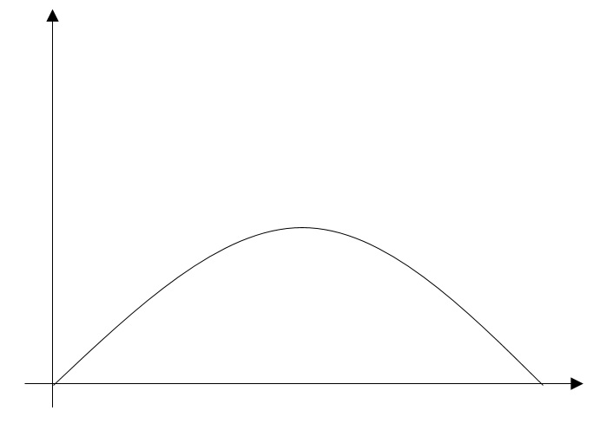
b
c
a
Figure 1. Parabola with instantaneous slopes
Figure 1, for example, shows a parabola. Three values of x are marked a, b, and c. At each of these points, the slope is a different value. At point a, the slope is positive, whereas at point c, the slope is negative. At point b, the slope is 0, so it is perfectly horizontal.
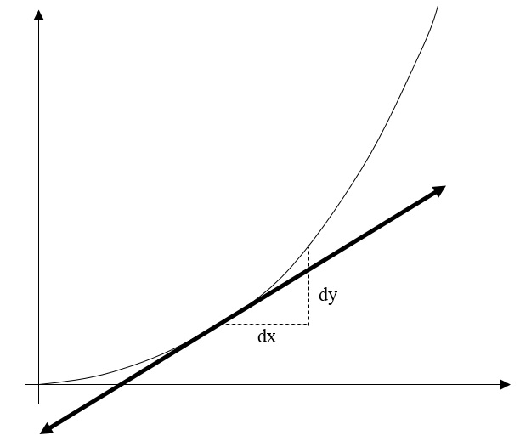
Figure 2. Graphical definition of the derivative
Figure 2 shows a parabola with the instantaneous rate of change given at a random point on the graph. The formula for the slope of a function is $Slope=\frac{Δy}{Δx}$, where $∆y$ is the change in y and $∆x$ is the change in x. The derivative is the instantaneous slope of a curve, where the change in y and the change and x both approach zero, hence making it “instantaneous”. When these two values approach zero, they become the differentials $dy$ and $dx$, as shown on the graph. Therefore, the derivative of a given function, $f\left(x\right)$, or $y$, is given as $\frac{dy}{dx}$. The limit notation for this is as follows:
$$\frac{dy}{dx}=\lim_{h→0}{\frac{f\left(x+h\right)-f(x)}{h}}$$
“h” is used as an extremely low value that is added or subtracted from x that would make the change in x, $∆x=\left(x+h\right)-(x)$, equal to just h, a number that approaches zero.
The integral has two main parts – the indefinite integral and the definite integral. The integral comes from the word “integrate”, which literally means to combine two or more parts to make a whole. Essentially, taking the integral of a function is finding the exact area under a curve.
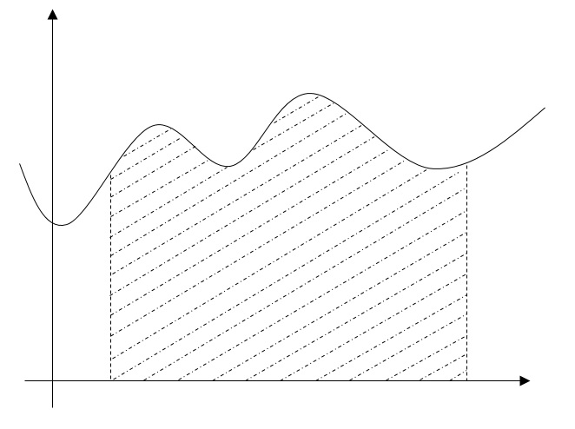
b
a
Figure 3. Area under a curve
Figure 3 shows that the definite integral of any given function, between two arbitrary points a and b, is really just the area under that function, between the two limits of integration. If the function is linear, finding the area underneath is not hard at all – this would be done by finding the area of either a rectangle, a triangle, or a trapezoid, depending on the slope and y-intercept of the function. If a function is not linear, however, different methods need to be used to find the area under it.
The definite integral of a function, given two limits of integration, would give the exact area under the function. This is done by using the indefinite integral (we will see these two concepts work together later when discussing the Fundamental Theorem of Calculus). The indefinite integral of a function is essentially a function whose derivative is equal to the original function. Because of this, the indefinite integral is also called the “antiderivative”. This also establishes how the derivative and the integral have an inverse relationship – one undoes the other. In other words, taking the derivative of an integral would essentially give you the original function (we will see these two concepts work together later when discussing the second part of the Fundamental Theorem of Calculus).
We’ve seen that integrals and derivatives have this inverse relationship with each other. Now, how are these relationships applied to the real world? In physics, many quantities deal with change. Those quantities are going to be the ones that involve derivatives and integrals. If something changes, there must be some sort of rate of change that happens as it changes, and with that comes calculus.
One of the most well-known applications is the relationship between the three quantities of displacement, velocity, and acceleration. Given a graph of velocity, the integral (or the function of the values of the area under the curve) would be a graph of displacement, and the derivative (or the function of the values of the rate of change at every x-value) would be a graph of acceleration. In the same way, the derivative of a displacement graph would be a graph of velocity, and the integral of an acceleration graph would be a graph of velocity.
Velocity (m/s)
Time (sec)
Figure 4. Graph of velocity
Figure 4 shows a graph of velocity. Perhaps the velocity is given as $v\left(t\right)=2t$, where $t$ is time. Time, in seconds, acts as the independent variable, whereas velocity, in meters per second, acts as the dependent variable. Now, the calculus behind this graph deals with derivatives (slopes) and integrals (areas). The calculus relationships associated with the given velocity function are as follows:
$$\frac{dv}{dt}=a \left(Acceleration\right)$$
$$\int{v dt}= \int{\frac{dx}{dt}dt}=\int{dx}=x \left(Displacement\right)$$
The derivative of velocity should be acceleration, and the integral of velocity should be displacement. The substitution can be made that velocity is essentially the rate of change of displacement, which is why it happens to work out algebraically that $\int{v dt}=\int{dx}$.
As for the reasoning behind these two properties, refer back to Figure 4. If the derivative of a function is the instantaneous slope of the function at a given point, and if the slope is constant for the entire function, than it makes sense that in this case, the slope of the line, 2, is the acceleration, which is constant. This also makes sense because the formula for slope can be used to give the units of the slope:
$$Slope=\frac{Rise}{Run}=\frac{dv}{dt}=\frac{(\frac{m}{s})}{s}=\left(\frac{m}{s^{2}}\right)←Unit for acceleration‼$$
The differential $dv$ accounts for the change in velocity, whose units are m/s, and the differential $dt$ accounts for the change in time, whose unit is seconds. This simplifies down to m/s², which just so happens to be the unit for acceleration!
Velocity (m/s)

Acceleration (m/s²)

Time (sec)

Time (sec)

Figure 5. Graphs for velocity and acceleration compared
Figure 5 shows a side-by-side comparison of the graphs for velocity and acceleration. Because the slope is constant for velocity, it makes sense that acceleration would be constant. As for the reasoning behind the integral property, again refer back to Figure 4. If the integral of a function is the area under the function, then the integral of the velocity function would be the area of the triangle that the graph makes, from $x=0$ to $x=a$, some arbitrary number. The integral function would then be the values of all of these areas, at each x-value. The area of the triangle, as x increases, will grow exponentially. For example, at $x=1$, the area would be $A=\frac{1}{2}bh=\frac{1}{2}\left(1\right)\left(2\right)=1 unit^{2}$, at $x=2$, the area would be $A=4 units^{2}$, at $x=3$, the area would be $A=9 units^{2}$, and so on. So, it would make sense that the integral function would be a parabola. The units can also be found by using the basic formula for area, as shown below:
$$Area=Base*Height=dt*\frac{dx}{dt}=\left(s\right)*\left(\frac{m}{s}\right)=m←Unit for displacement!$$
The substitution that velocity is just the change in displacement over the change in time can be made, showing that when you find the area under a velocity function, the resulting integral is displacement!
Velocity (m/s)

Displacement (m)

Time (sec)

Time (sec)

Figure 6. Graphs for velocity and displacement compared
Figure 6 shows a side-by-side comparison of the graphs for velocity and displacement. Because the area under the velocity graph grows exponentially, it makes sense that the function for displacement would be a parabola.
Another application of this relationship is the fact that given a graph of the potential energy of a particle as a function of displacement, the negative derivative of the function will be the force exerted on the particle. Because the derivative and integral have an inverse relationship, this would mean that the negative integral of the force exerted on a particle as a function of displacement is the potential energy of the particle. Not to make the explanation too physics-based, but the derivative and integral values are negative for a reason. If, for example, gravity is exerting the force, the potential energy would be the amount of work done against that force to get it moving. This occurs in every force/potential energy scenario, so it is a general rule that the signs of the derivative and integral are negative.
This example is much like the previous example, where the units of the derivative or the integral can be found by using basic formulas for slope and area, with the units given on the x- and y-axes. For example, on a graph of potential energy as a function of displacement, the units on the x-axis are meters and the units on the y-axis are joules, or $kg*m^{2}/s^{2}$. So, the derivation of the units of the derivative is as follows:
$$Slope=\frac{Rise}{Run}=\frac{dU}{dx}=\frac{(kg*m^{2}/s^{2})}{m}=\left(kg*m/s^{2}\right)=Newtons←Unit for force‼$$
As shown, the meters from the units of the x-axis allow for one of the meters in the units for potential energy to be cancelled out, creating the product of units for mass and acceleration, which is force! As for the inverse, the derivation of the units of the integral are as follows:
$$Area=Base*Height=dx*\frac{dU}{dx}=\left(m\right)*\left(kg*\frac{m}{s^{2}}\right)=\left(kg*\frac{m^{2}}{s^{2}}\right) ←Unit for GPE!$$
As shown, the meters from the units of the x-axis allow for the meters in the units for force to be squared, creating the product of units for mass, acceleration, and height, which is gravitational potential energy!
Derivatives themselves can be used to determine important features on a graph, including maximums, minimums, and points of inflection. These are all called critical points. The true definition of a critical point is a point where the derivative is zero or undefined. Derivative functions, as well as second derivative functions, can tell a lot about a function, and can show where these critical points lie.
Point of inflection
Local minimum
Local maximum
Figure 7. Function with critical points labeled
Figure 7 shows a random curve with the main critical points labeled. The curve has a local maximum (where the function reaches a peak, or a high point), a local minimum (where the function reaches a low point), and a point of inflection, where the concavity of the graph changes. These things can be found by analyzing derivative functions. Derivative functions, as explained earlier, are functions that give the slope of the original function at all given points of that function.
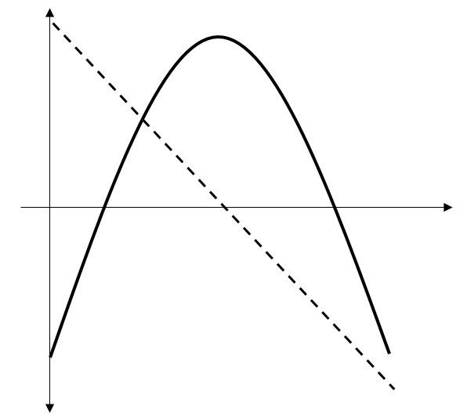
Figure 8. Maximums occur when the derivative function is zero
Figure 8 shows a parabola and its derivative’s graph, a dotted linear function. The derivative function shows that the slope of the original function begins positive and decreases at a constant rate. It also shows that the original function has a maximum when the derivative function is zero. This makes sense, because the rate of change of any function at a maximum or minimum is going to be zero. In other words, the instantaneous slope, or the slope of the tangent line at that point, will be zero. So, in general, if the graph of the first derivative is given, then it is reasonable to assume that whenever that graph has a value of zero, the slope on the original function at that point would also be zero, indicating a maximum or minimum.
Second derivative graphs are also useful in finding critical points, but are mainly good for showing the concavity of the original function.
Concave down
Concave up
Figure 9. Concavity
Figure 9 shows the two different types of concavity. Concavity tells whether the graph is facing up or down, and allows us to see how fast or how slow something is changing. If a function passes a maximum (concave down), that would mean that as it is increasing, the slope will get smaller, which will make whatever is changing, change slower. The same applies for a function that passes a minimum (concave up) – as it increases, the slope will get higher, telling us that whatever is changing will change faster. The point where concavity changes is known as a point of inflection. These points can be found in both first and second derivatives of the original graph. Where the second derivative is zero, the original graph can be neither concave up nor concave down. So, it must be the one point where it changes; however, this is only the case when the second derivative crosses the x-axis. If it touches the x-axis, but lifts off in the opposite direction as opposed to continuing through it, the concavity stays the same. Now, given that when the second derivative is zero is when there is a point of inflection, it is reasonable to suggest that when the derivative, or the slope, of the first derivative is zero, or when it is at a maximum or minimum, there will be a point of inflection.
The signs of the first and second derivative functions, or whether the first and second derivatives are positive, negative, or zero, also tell a lot about the original function. If the first derivative is positive in some interval, this would mean that the slope of the original function is positive, indicating that it is increasing. When the first derivative is negative in some interval, the slope of the original function would also be negative, indicating that it is decreasing. As explained earlier, when the first derivative is zero, the slope of the original function would be zero as well, indicating a maximum or minimum. So, the sign of the first derivative graph tells us how the original function changes.
The sign of the second derivative tells us a lot about the original function as well. As explained earlier, the second derivative is used to determine the concavity of the original function. If the second derivative is positive in some interval, this would mean that the original function is concave up. Similarly, when the second derivative is negative in some interval, this would mean that the original function is concave down. As explained earlier, when the second derivative is zero, concavity is neither up nor down, so it must be changing. So, when the second derivative is zero, there is a point of inflection. So, the sign of the second derivative graph tells us how fast the original function changes. It also tells us how the first derivative changes, as it is also the first derivative of the first derivative function.
The first and second derivative functions can also be used to find the properties of the original function that the other would usually find. In other words, the first derivative can be used to find concavity and points of inflection, and the second derivative can be used to find maximums and minimums.
The second derivative tells us the slope of the first derivative function. So, if the first derivative has a positive slope, then the second derivative will have a positive value. This scenario looks familiar: when the second derivative is positive, the concavity of the original function is also positive. So, we can make the conclusion that when the slope of the first derivative is positive, the concavity of the original function will be positive. In general, the slope of the first derivative tells us the concavity of the original function. For example, whenever the first derivative has a maximum or minimum, the slope is zero, so the second derivative is also zero, indicating a point of inflection.
If a given first derivative function is zero, and we know nothing about the original function, we will not know if that point on the original function is a maximum or a minimum. This is what the second derivative is useful for. Known as the second derivative test, the second derivative can be used to find whether this value is a maximum or minimum. For example, if the first derivative is zero, and the second derivative is positive, that would mean that the original function is increasing (recall that the second derivative tells us whether the original function is increasing or decreasing). The only way that a function can increase from a slope of zero is if it were at a minimum. So, in general, if the first derivative is zero, the sign of the second derivative can tell us if it is a maximum or a minimum: if the second derivative is positive, there is a minimum, and if the second derivative is negative, there is a maximum.
Integrals and derivatives are obviously a huge part of calculus. So much so that they are the two fundamental concepts that govern the Fundamental Theorem of Calculus. The Fundamental Theorem of Calculus has two parts that both define properties of the definite integral.
The definite integral of some function is the numerical value of the area under a curve. It is represented in the following way:
$$\int_{a}^{b}{f\left(x\right) dx}=F\left(b\right)-F(a)$$
In the equation, the area under the curve $f\left(x\right)$ is equal to the difference of the indefinite integral $F(x)$ evaluated at b and the indefinite integral evaluated at a. The explanation behind this is actually fairly straightforward. The indefinite integral of a function, also known as the function’s “antiderivative”, will give the area under the function from the origin when evaluated at any point. So, what happens when you are trying to find the area under a curve between two arbitrary points a and b?
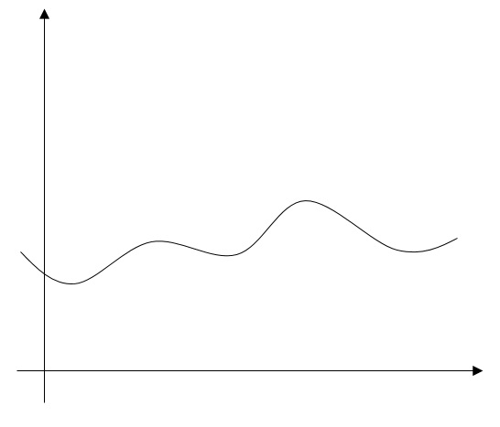
Figure 10. The graph of an arbitrary function
Figure 10 shows an arbitrary function. The goal here is to find the area under the curve between two points. In order to do that, let’s explore why the exact area under this curve will simply be the difference between the values of the indefinite integral evaluated at these two points.
b
a
Figure 11. Two points labeled “a” and “b”
Figure 11 shows the two points of reference for this problem. Let’s first look at the area under the curve from the origin to each value.
a
Figure 12. Area under curve from $x=0$ to $x=a$
Figure 12 shows the area under the curve from $x=0$ to $x=a$. Because the area under a function, $f(x)$, from the origin to a given point is the indefinite integral evaluated at that point, we will call this area $F(a)$, where $F(x)$ is the antiderivative of $f(x)$.
b
Figure 13. Area under curve from $x=0$ to $x=b$
Figure 12 shows the area under the curve from $x=0$ to $x=b$. For the same reason as the previous area, we will call this area $F(b)$.
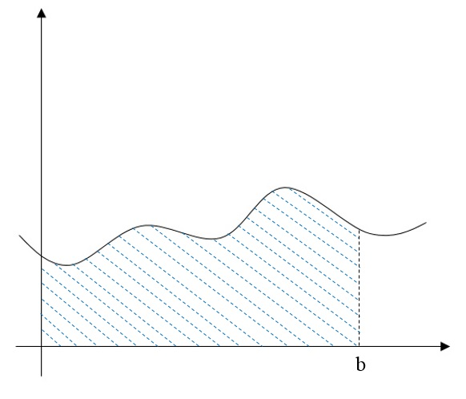
a
Figure 13. Area under curve from $x=a$ to $x=b$
Figure 13 shows a combination of the area under the curve from $x=0$ to $x=a$ and the area under the curve from $x=0$ to $x=b$. In other words, it is combination of the areas $F(a)$ and $F(b)$ that we defined earlier. In this graph, we see that the area $F\left(a\right)$ has overlap with the area $F(b)$. In fact, this overlap is the area $F(a)$. So, if we wanted the area under the curve between the points a and b, all we would have to do is take the entire area $F(b)$ and subtract the overlap with the area $F(a)$. Thus, the area under the curve from $x=a$ to $x=b$ is given by the expression $F\left(b\right)-F(a)$. Or, in proper integral notation, $\int_{a}^{b}{f\left(x\right) dx}=F\left(b\right)-F(a)$. That is why the Fundamental Theorem of Calculus works out so nicely.
The Fundamental Theorem of Calculus also has a second form. This form takes what we just learned and applies the derivative operator to it. The second form of the Fundamental Theorem of Calculus states the following:
$$\frac{d}{dx}\left(\int_{a}^{x}{f\left(t\right) dt}\right)=f\left(x\right)*x'$$
This essentially states that the derivative of an integral is the integrand evaluated at the given expression. Our upper limit of integration is simply x. This can really be any mathematical expression, but for ease of explanation, x was used. The $t$ was used as a placeholder so that the x can be used later.
Let’s now look at the deeper meaning behind this theorem. We can take the integral given and apply the first form of the Fundamental Theorem of Calculus to it. This would give the following:
$$\frac{d}{dx}\left(\int_{a}^{x}{f\left(t\right) dt}\right)=\frac{d}{dx}(F\left(x\right)-F\left(a\right))$$
This now becomes a bit easier to understand. The right side of the equation is very easy to take the derivative of. Applying the derivative operator to that expression gives the following:
$$\frac{d}{dx}\left(F\left(x\right)-F\left(a\right)\right)=F^{'}\left(x\right)*x'$$
The $x'$ in the right expression comes from the chain rule, as you must take the derivative of the inner function as well as the outer function. The derivative of the term $F(a)$ is simply 0 as it is a constant because the antiderivative was evaluated at some number $a$. The final part to this theorem is that the term $F'(x)$ holds its own meaning. We know that $F(x)$ is the antiderivative of $f(x)$. This MUST mean that $F^{'}\left(x\right)=f(x)$ due to the fact that derivatives and integrals are inverses of each other. Thus, $\frac{d}{dx}\left(\int_{a}^{x}{f\left(t\right) dt}\right)=f\left(x\right)*x'$.
$$\frac{d}{dx}\left(\int_{a}^{x^{5}}{\sqrt{1+t} dt}\right)=5x^{4}\sqrt{1+x^{5}}$$
Figure 14. Example of the second form of the FTC
Figure 14 shows an example that uses the chain rule to show the second form of the Fundamental Theorem of Calculus. The integrand was simply evaluated at $x^{5}$, and the derivative of that, $5x^{4}$, was included by the chain rule.
Two other huge theorems exist in calculus: the Intermediate Value Theorem and the Mean Value Theorem. These two theorems may seem like common sense, but they are both important to our understanding of calculus today.
The Intermediate Value Theorem states that if a given function $f$ is continuous for all x in $\left[a,b\right]$ (the closed interval from a to b), and $f(a)<y<f(b)$, then $∃$ (there exists) some number $c$ in $(a,b)$ (the open interval from a to b) such that $f\left(c\right)=y$. Essentially, given a continuous function, there will be a number c between a and b that will yield a y between $f\left(a\right)$ and $f(b)$. This theorem is very straightforward, as it basically proves that there will always be a value that is “intermediate” in respect to, or somewhere between, two values of a function.

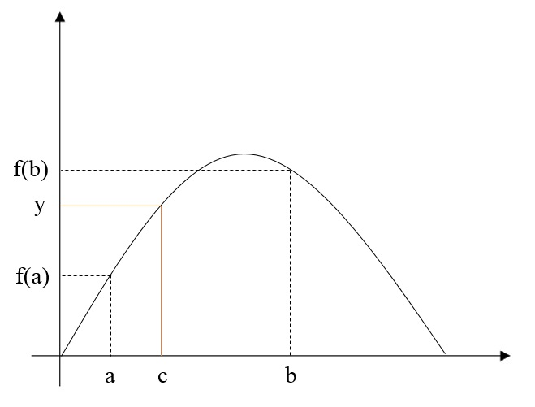
Figure 15. Intermediate Value Theorem
Figure 15 shows an illustration of the Intermediate Value Theorem, where $f\left(c\right)=y$. The other theorem, the Mean Value Theorem, has two parts: one that deals with derivatives, and one that deals with integrals.
The Mean Value Theorem for derivatives states that if a given function $f$ is differentiable for all x in $(a,b)$ and $f$ is continuous for all x in $\left[a,b\right]$ then $∃$ at least one number $c$ in $(a,b)$ such that $f^{'}\left(c\right)=\frac{f\left(b\right)-f(a)}{b-a}$. In other words, there will be a number c wherein the average rate of change between a and b, or the slope of the secant line from a to b, is equal to the instantaneous rate of change at $x=c$, or the instantaneous slope at $x=c$.
c
b
a
Figure 16. Mean Value Theorem for derivatives
Figure 16 shows an illustration of the Mean Value Theorem for derivatives, where the blue lines indicate the tangent and secant lines with equal slopes. The instantaneous slope at $x=c$ is equal to the slope of the secant line between $x=a$ and $x=b$.
The other part of the Mean Value Theorem is the Mean Value Theorem for integrals. This theorem states that if a given function $f$ is continuous on $[a,b]$, then $∃$ a number $c$ in $[a,b]$ such that $f\left(c\right)=\frac{1}{b-a}\int_{a}^{b}{f\left(x\right) dx}$. In other words, this function proves that a continuous function will have at least one point wherein the function evaluated at that point will equal the average value of the function.
c
b
a
Figure 17. Mean Value Theorem for integrals
Figure 17 shows an illustration of the Mean Value Theorem for integrals. In the graph, the value of the function at $x=c$ creates a rectangle with length $b-a$. The area of this rectangle is equal to the area under the curve from $x=a$ to $x=b$. The area under the curve above the rectangle matches with the empty part inside of the rectangle, which makes the two equal.
The definite integral has one last property that is fairly simple to understand. The property is given by the following:
$$\int_{a}^{b}{f\left(x\right) dx}=-\int_{b}^{a}{f\left(x\right) dx}$$
This property states that if the limits of integration are reversed, then the integral will have the same absolute value, but the reversed integral will be negative. Let’s take a look at why this occurs.
b
a
Figure 18. Definite integral from a to b
Figure 18 shows the area under a curve from $x=a$ to $x=b$. The definite integral essentially takes the area you want, slices it up into infinitely skinny rectangles, and sums up all of the areas of those rectangles. The rectangles would have a height of $f(x)$ and a width of $dx$. In Figure 18, the value of $dx$ was exaggerated for the purpose of explanation. The area under this curve would be given by $\int_{a}^{b}{f\left(x\right) dx}$. What if the limits of integration were reversed? Then, you would be integrating from $x=b$ to $x=a$. In this case, the value of $dx$ would be negative because you are integrating in the opposite direction, or towards the origin. This negative $dx$ value would in turn make the entire integral negative. Therefore, the following can be declared true:
$$\int_{a}^{b}{f\left(x\right) dx}=\int_{b}^{a}{f\left(x\right) (-dx)}=-\int_{b}^{a}{f\left(x\right) dx}$$
The negative on the $dx$ can be moved to the outside of the integral to make the previously declared statement true.
Now that we have gained an understanding of the topic, let’s apply these properties and rules to problems from an AP Calculus test!
The Problems
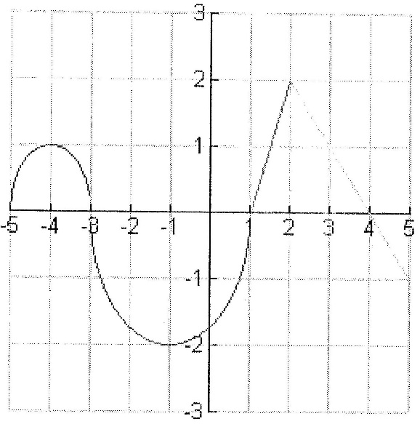
Figure 19. Graph for Problem 1
Figure 19 gives the graph that will be used for all parts in Problem 1. The scenario for Problem 1 reads the following: “Let $f$ be a function defined on $[-5,5]$ with $f\left(1\right)=3$. The graph of $f'$, the derivative of $f$, consists of two semicircles and two line segments, as shown below.” This derivative graph is the one shown in Figure 19.
Part (a) of Problem 1 reads the following: “For $-5<x<5$, find all values x at which $f$ has a relative maximum. Justify with calculus.” As we learned earlier, whenever the derivative graph is zero, that indicates a maximum or minimum on the original function. So, the possible contenders for this problem are $x=-3, 1, and 4$. The second derivative test will tell us which of these is/are relative maximums. Whenever the derivative graph has a negative slope, the second derivative graph will be negative. When the second derivative is negative, the original function has a maximum, which we learned earlier. In this example, the slope is negative when is crosses the x-axis at the points $x=-3$ and $x=4$. So, the original function has a relative maximum at the points $x=-3$ and $x=4$.
Part (b) of Problem 1 reads the following: “For $-5<x<5$, find all values x at which the graph of $f$ has a point of inflection. Justify.” As we learned earlier, points of inflection occur when the second derivative is zero. This also means that points of inflection occur when the first derivative graph has a slope of zero, or when it is at a maximum or minimum. This occurs at three different points on the graph: $x=-4, -1, and 2$. So, the original function has a point of inflection at $x=-4$, $x=-1$, and $x=2$.
Part (c) of Problem 1 reads the following: “Find all intervals on which the graph of $f$ is concave up and also has a positive slope. Justify.” We know that the value of the second derivative tells us the concavity of the original function. This means that the slope of the first derivative does the same. Whenever the slope of the first derivative is positive, the concavity of the original function will also be positive. This occurs in two different intervals: $-5<x<-4$ and $-1<x<2$. However, this is NOT the final answer. These intervals are when the original function is concave up, but the slope may or may not be positive. We know that the slope will be positive on the original function if the value of the first derivative is positive. So, wherever the first derivative is (a) positive, and (b) increasing, the original function will be both concave up AND have a positive slope. This occurs within two intervals: $-5<x<-4$ and $1<x<2$.
Part (d) of Problem 1 reads the following: “Find the absolute minimum value of $f(x)$ over $[-5,5]$. Justify.” This, at first, seems like it will be a fairly straightforward problem. We found the maximums, so finding the minimums should not be that difficult. However, we need the absolute minimum. This means that either of the endpoints of the graph could also be the absolute minimum. So, we just have to make sure to check those endpoints. But first, let’s find the minimum that is given from the graph. We know that there were three possible contenders: $x=-3, 1, and 4$. If there is a maximum at $x=-3$ and $x=4$, then there must be a minimum at $x=1$. But is this the absolute minimum? Let’s check the endpoints…
In order to check the endpoints, we must find the area under the first derivative graph from $x=1$ to each endpoint. The original function gives values of the area under the first derivative graph, from the origin. So, if we find these values, we will know if they reach lower than the minimum at $x=1$. We were given that $f\left(1\right)=3$, so if the value of the function at $x=-5$ or $x=5$ is greater than three, then those endpoints are NOT absolute minimums. First, let’s define $f(x)$ to be $f\left(x\right)=3+\int_{1}^{x}{f^{'}\left(t\right) dt}$. If the value of the integral is greater than zero, then the endpoint will not be an absolute minimum.
For the first endpoint, $x=-5$, some geometry can be used to find the area under the curve because we know that the two parts of the graph before $x=1$ are both semicircles. Those areas should be easy to find. By plugging in -5, $f\left(-5\right)=3+\int_{1}^{-5}{f^{'}\left(t\right) dt}$. We can then reverse the limits of integration to make $f\left(-5\right)=3-\int_{-5}^{1}{f^{'}\left(t\right) dt}.$The integral will be the negative, or opposite of the area under the curve before $x=1$. Knowing this, the area of the first semicircle, from $x=-5$ to $x=-3$, is given by the following:
$$\int_{-5}^{-3}{f^{'}\left(t\right) dt}=\frac{1}{2}π(1)^{2}=\frac{π}{2}$$
The area of the first semicircle is $\frac{π}{2} units^{2}$. Similarly, the area of the second semicircle, from $x=-3$ to $x=1$, is given by the following:
$$\int_{-3}^{1}{f^{'}\left(t\right) dt}=-\frac{1}{2}π(2)^{2}=-2π$$
The area of the second semicircle is $-2π units^{2}$. So, the endpoint can be checked by the following:
$$f\left(-5\right)=3-\left(\frac{π}{2}-2π\right)=3+\left(2π-\frac{π}{2}\right)=3+\frac{3π}{2}$$
$f(-5)$ is equal to $3+\frac{3π}{2}$. Because this value is greater than 3, it is NOT the absolute minimum.
For the second endpoint, $x=5$, the limits of integration do not have to be reversed, and finding the area is easier because now, we are dealing with line segments. By plugging in 5, $f\left(5\right)=3+\int_{1}^{5}{f^{'}\left(t\right) dt}$. The integral here can be done by counting squares.
Figure 20. Area between $x=1$ and $x=5$
Figure 20 shows us a counting-squares method of finding the area under the graph from $x=1$ to $x=5$. The blue triangle has an area of 1 unit². This just comes from the area of a triangle formula. The area of the three orange triangles are 0.5 units² each, as they each take up half of a square. Lastly, the area of the green square is simply 1 unit². The total area is the difference of the area above the x-axis and the area below the x-axis, so it is given by the following:
$$Area=3-0.5=2.5 units^{2}$$
This area can be added to the integral for the endpoint. This is given by the following:
$$f\left(5\right)=3+\left(2.5\right)=5.5$$
Because this value is greater than three, this endpoint is not the absolute minimum. Therefore, the absolute minimum is the one that occurs at $x=1$.
Part (e) of Problem 1 reads the following: “Let $g$ be the function given by $g\left(x\right)=\int_{1}^{x}{f^{'}\left(t\right) dt}$. Find $g(3)$, $g'(3)$, and $g''(3)$. Justify.” For the first value, $g(3)$, we can plug in 3 so get $g\left(3\right)=\int_{1}^{3}{f^{'}\left(t\right) dt}$. This is essentially just the area under the graph from $x=1$ to $x=3$. By looking at Figure 20, we see that this area is 2.5 units². So, $g\left(3\right)=2.5$.
For $g'(3)$, we can use the second Fundamental Theorem of Calculus. $g'(x)$ should be given by $g^{'}\left(x\right)=\frac{d}{dx}\left(\int_{1}^{x}{f^{'}\left(t\right) dt}\right)=f'(x)$. Because of this, we can declare that, by looking at the graph of the first derivative, $g^{'}\left(3\right)=1$.
For $g''(3)$, we can simply use the slope of the first derivative graph at the point $x=3$, because that will give us the second derivative’s value at that point. Because of this, we can declare that, by taking the slope at $x=3$, $g^{''}\left(3\right)=-1$. That is the conclusion of Problem 1.
Table 1
Table for Problem 2
X | F(x) | F’(x) | G(x) | G’(x)
1 | 3 | 4 | 2 | 5
2 | 9 | 2 | 3 | 1
3 | 10 | -4 | 4 | 2
4 | -1 | 3 | 6 | 7

Table 1 shows the table that will be used throughout Problem 2. The scenario for Problem 2 reads the following: “The functions F and G are differentiable for all real numbers, and G is strictly increasing. The table below gives values of the functions and their first derivatives at selected values of x. The function H is given by $H\left(x\right)=F\left(G\left(x\right)\right)-6$.”
Part (a) of Problem 2 reads the following: “Use calculus concepts to explain why there must be a value r for $1<x<3$ such that $H\left(r\right)=-5$.” We can use the Intermediate Value Theorem to show this. To do so, we must first find H(1) and H(3). H(1) and H(3) is given by the following:
$$H\left(1\right)=F\left(G\left(1\right)\right)-6=F\left(2\right)-6=9-6=3$$
$$H\left(3\right)=F\left(G\left(3\right)\right)-6=F\left(4\right)-6=-1-6=-7$$
Because $H\left(3\right)<-5<H(1)$, and because H is continuous, by the Intermediate Value Theorem, $∃$ a value r, with $1<r<3$, such that $H\left(r\right)=-5$.
Part (b) of Problem 2 reads the following: “Use calculus concepts to explain why there must be a value c for $1<c<3$ such that $H^{'}\left(c\right)=-5$.” We can use the Mean Value Theorem to show this. To do so, we must find the average rate of change between $x=1$ and $x=3$. This can be given by the following:
$$H^{'}\left(c\right)=\frac{H\left(3\right)-H(1)}{3-1}=\frac{-7-3}{3-1}=-5$$
The values for H(3) and H(1) were taken from the previous problem. Because H is continuous and differentiable, by the Mean Value Theorem, $∃$ a value c, with $1<c<3$, such that $H^{'}\left(c\right)=-5$.
Part (c) of Problem 2 reads the following: “Let w be the function given by $w\left(x\right)=\int_{1}^{G(x)}{F\left(t\right) dt}$. Find the value of w’(3).” We can use the second Fundamental Theorem of Calculus to show the following:
$$w^{'}\left(x\right)=F\left(G\left(x\right)\right)*G'(x)$$
Now, by plugging in 3, we can find the value of w’(3). This is shown by the following:
$$w^{'}\left(3\right)=F\left(G\left(3\right)\right)*G^{'}\left(3\right)=F\left(4\right)*G^{'}\left(3\right)=-1*2=-2$$
So, $w^{'}\left(3\right)=-2$.
Part (d) of Problem 2 reads the following: “If G⁻¹ is the inverse function of G, write an equation for the line tangent to the graph of $y=G^{-1}(x)$ at $x=2$.” This concept was not written in the paper, but is easy to explain. In order to write the equation of the line tangent to an inverse function, we must first know what the value of the function is, and then find the derivative function so that we can find the slope of the line. First off the value of the function at $x=2$ is fairly simple to find. We know, by looking at Table 1, that G(1) is 2. Inverse functions take the x and y values and switch them. So, $G^{-1}\left(2\right)=1$. Let’s add this in a separate table, Table 2.
Table 2
Problem 2, Part (d)
X | F(x) | F’(x) | G(x) | G’(x) | G⁻¹(x)
1 | 3 | 4 | 2 | 5 | -
2 | 9 | 2 | 3 | 1 | 1
3 | 10 | -4 | 4 | 2 | -
4 | -1 | 3 | 6 | 7 | -

Table 2 shows the additional column for G⁻¹(x). The other three values in that column will not matter, because we are only finding the line tangent to the graph at $x=2$. Now, in order to find the slope, we must find the derivative of G⁻¹(x). The derivation of this is below in Figure 21, by using implicit differentiation.
$$y=G^{-1}\left(x\right), so G\left(y\right)=x$$
$$By implicit differentiation…$$
$$G^{'}\left(y\right)*y^{'}=1$$
$$y^{'}=\frac{1}{G^{'}\left(y\right)}=\frac{1}{G'(G^{-1}\left(x\right))}$$
Figure 21. Derivation of G⁻¹’(x)
Figure 21 shows that the derivative of G⁻¹(x) can be given by ${G^{-1}}^{'}\left(x\right)=\frac{1}{G'(G^{-1}\left(x\right))}$. Given this, we can find the value of the slope at $x=2$ by plugging in 2. The slope at that point is given by the following:
$$Slope=\frac{1}{G'(G^{-1}\left(2\right))}=\frac{1}{G'(1)}=\frac{1}{5}$$
Now that we know that the slope is $\frac{1}{5}$, we can plug all of the information into the point-slope formula and simplify to get the equation of the line tangent to the graph at $x=2$. This is given by the following:
$$y=\frac{1}{5}\left(x-2\right)+1=\frac{1}{5}x-\frac{2}{5}+1=\frac{1}{5}x+\frac{3}{5}$$
So, the equation of the line tangent to the graph $y=G^{-1}(x)$ at the point $x=2$ is $y=\frac{1}{5}x+\frac{3}{5}$.
Part (e) of Problem 2 reads the following: “If $H\left(x\right)=x*B(x)$, where $B\left(x\right)=F^{-1}(x)$, use the table to find H’(3).” We can use the same concept from the last problem to do this one. First, let’s find the derivative of H(x) by using the product rule:
$$H^{'}\left(x\right)=B\left(x\right)+x*B^{'}\left(x\right)=F^{-1}\left(x\right)+x*F^{-1}'(x)$$
Now that we have the equation, let’s make another table to find F⁻¹(3). This is given as Table 3 below.
Table 3
Problem 2, Part (e)
X | F(x) | F’(x) | G(x) | G’(x) | F⁻¹(x)
1 | 3 | 4 | 2 | 5 | -
2 | 9 | 2 | 3 | 1 | -
3 | 10 | -4 | 4 | 2 | 1
4 | -1 | 3 | 6 | 7 | -

Table 3 shows us that F⁻¹(3) would be 1, because F(1) is 3. By using the same formula for the derivative of an inverse, we can find F⁻¹’(3). This is given by the following:
$${F^{-1}}^{'}\left(3\right)=\frac{1}{F'(F^{-1}\left(3\right))}=\frac{1}{F'(1)}=\frac{1}{4}$$
Now, we have all of the numbers that we need to answer the question. By plugging in 3, we get the answer from the following:
$$H^{'}\left(3\right)=F^{-1}\left(3\right)+x*{F^{-1}}^{'}\left(3\right)=1+3\left(\frac{1}{4}\right)=1+0.75=1.75$$
So, $H^{'}\left(3\right)=1.75$. That is the conclusion of Problem 2.

