Brendan Nowakowski
Mrs. Candela – 4th and 5th Hour
Career Field Experience
17 May 2015
Reflection on Career Field Experience
“Teaching creates all other professions.” –Author Unknown. This is the perfect quote related to my experience in Career Field Experience because it is true, and I believe that teaching mathematics opens up so many new opportunities in terms of careers for students to go into after college. In my Career Field Experience class, I was required to be a student teacher for the AP Calculus teacher at Lake Shore High School. In the weeks of doing so, I would write a blog to document the experience. In my opinion, Career Field Experience was a unique class because it gave me the opportunity to get a feel for what I would do after college. For eight weeks, I taught students various lessons, helped them study for quizzes, prepared them for the AP Calculus AB test, and graded their assignments as they turned them in. While reflecting on my overall learning experience in this class, I will outline my communication skills, my flexibility skills, and my leadership skills.
One skill set of mine that has improved over the course of eight weeks in this class are my communication skills. I have been teaching students various lessons, and at first, I was very nervous, never having taught a real class before. I did not know what to expect, or how the students would react, so I was nervous. However, I saw that the students were understanding what I was saying because they spoke the same, mathematical, language that I speak. That helped immensely, and allowed my communication skills to really start to improve. It has even helped me with my presentation skills, a subset of skills under the communication subject. These skills were implemented at my advanced placement school, the Macomb Mathematics Science Technology Center, where presentations are much more of a regular activity.
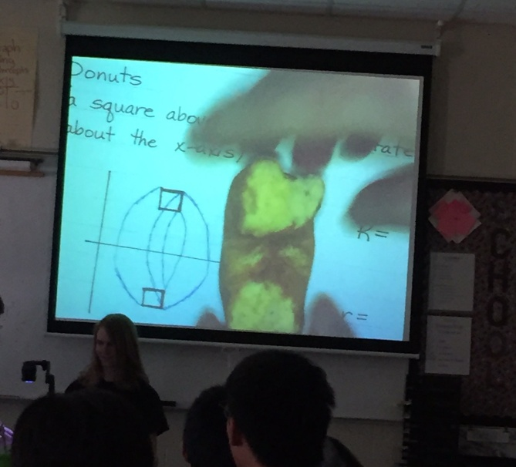
Figure 1. Communication skills
Figure 1 shows me using a donut to explain the lesson on finding the volume of solids by using the “washer” method. One of the ways to use the “washer” method is by imagining a donut. Here, I am showing the students how the cross section of a donut looks like a square being revolved around an axis. My communication skills were important here because some of the students may have a hard time visualizing a square being revolved around an axis. Having a real life example, like a donut, made it easier for them to visualize the revolved square.
Another skill set that has improved for me are my flexibility skills. Being a teacher, you have many different responsibilities, and when all of those responsibilities stack up on you, it can feel overwhelming. Teaching, grading, making sure everybody is behaving and doing their job, and explaining or doing something on the spot; these are just some of the things that teachers have to make sure they do every day. My supervisor, Mrs. Roda, would give me something new to do every day, and I had no choice but to do what she said. Being flexible, I would take on any challenges that came my way, and would adapt well to a new setting every time the plans changed. Being flexible as a teacher is very important, because if you do not have those skills, you will not be able to communicate well with your students, and those connections that help them learn will be lost.
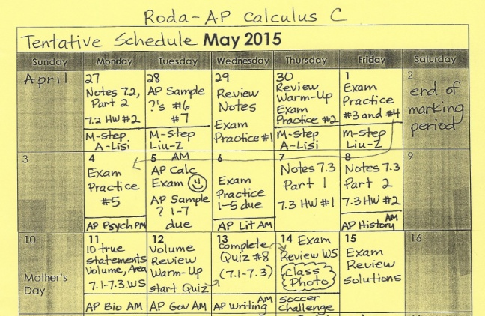
Figure 2. Flexibility skills
Figure 2 shows a calendar that Mrs. Roda had made for her students for the last month of school. In it, I have arrows drawn in to show that some assignments would be moved from day to day. In those cases, I would have to be flexible and adapt to my new role that day. While this did not happen every day, it happened quite a lot, and it takes some getting used to. Being a teacher, you have to deal with these types of cases every day, so it is important to become more flexible with your job.
The last skill set of mine that has greatly improved over the course of this experience are my leadership skills. I have not had many leadership positions throughout high school, the only prominent one being that I was a section leader of the drum line in band. Being a teacher, you are the leader of the classroom. You must control twenty to thirty students at a time, and that can be tricky, unless you truly know how to be a leader. Of course, there were never times that I would have to “lay down the law” as that was their actual teacher’s job. I will learn more of those skills in college. This class has helped me lead the classroom more than a few times, and has really taught me that being a leader is not so hard, if you are able to communicate with your students and be flexible with them. All of the skill sets that I have brought up are interconnected in some way, and with communication and flexibility skills come leadership skills.
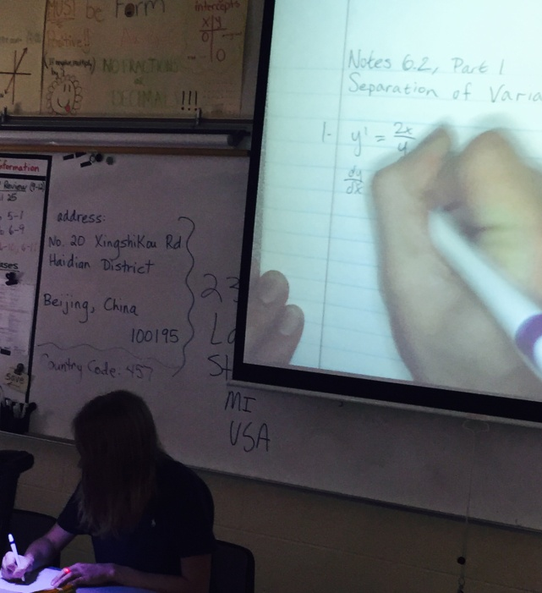
Figure 3. Leadership skills
Figure 3 shows me teaching a lesson, one of the easiest ways to express leadership when you are a teacher. Here, I have all of my students’ attention, and they look up to me as their teacher. This becomes a very important part of teaching, when students can look at you as a leader of the classroom.
This class has changed how I look at teaching. It was originally a little intimidating, and now I know that it is not really that difficult. Instead, it is a lot of fun, if you are teaching something that you are passionate about. I am passionate about mathematics, and that helps me communicate those skills in that language. I would not be able to do so without having an enthusiastic attitude towards math. One moment that I will never forget from this experience is the last day, when all of the students, especially the Chinese foreign exchange students, were saying their goodbyes to me. I knew then that I had made a positive impact on them and their learning, and it was a very relieving and bittersweet moment. I will always hope that they remember me like I remember them. In closing, I would definitely recommend this class to others because it allows you to do your dream job before doing your dream job. It lets you see what it is like, so that you can figure out if that is what you really want to do after college. I have found that I just want to teach more than I originally wanted to, especially knowing that I would have my own classroom, and that maybe someday, I could have a student teacher of my own.

