Robert Martin and Brendan Nowakowski
Mrs. Tallman
AP Calculus
4 February 2015
Lead Contamination Reflection
Lead used to be a metal that we could trust. According to Steve Gagnon, anywhere from its uncanny protection from corrosion that allows for acid storage and plumbing, to its durability that allows for reliable ammunition, lead is a very useful element ("The Element Lead"); however, we are advancing our knowledge on how much of a mistake the lead era was. In the last couple of decades of research, scientists and medical professionals have realized that even the slightest intake of lead could have permanent, detrimental effects not only to the human body, but to the environment and its ecosystems as well. How lead exposure occurs, the dangers of lead exposure, and the ways to minimize lead exposure should all be discussed nationwide to help prevent more lives from being affected by this dangerous element.
As previously stated, lead was one of the most commonly used metals in the plumbing of buildings during the 1900s. Furthermore, lead was used in gasoline and paints due to the fact that it helped preserve the products and their effectiveness ("Lead Poisoning"). Now, you have to ask yourself: "how does lead exposure actually occur?" This is an important question because, even though lead was used in the above kinds of products, that doesn't immediately explain how the exposure occurred.
In regards to the pluming and gasoline it’s simple. If any of the lead in the pipes were to erode away into the water being run through to a faucet, for example, then anything to consume that water would be ingesting the lead particles. Similarly, anything to inhale the exhaust fumes that were released from automobiles during the leaded gas era would have also been ingesting tiny particles of lead. In regards to the paint, however, the circumstances leading up to the poisoning are a little more complicated. Firstly, if a child, for example, were to eat any lead paint chips, whether it be from a wall or a painted toy, the child would be ingesting straight poison (this does not imply that eating lead-free paint chips is healthy however). Secondly, if a new homeowner of a house that contained lead paint were to repaint the house, any inhalation of the lead paint dust resulting from sanding would be direct ingestion of poison as well. It should be noted that the above scenarios are just common examples, and that lead poisoning can occur in any situation pertaining to products that contain lead. Though, one common theme looms over lead ingestion: over long periods of time, the accumulation of lead in the system could lead to disastrous consequences.
When lead enters the body through the various ways described above, many different things happen. First off, lead moves through different sections of the body through transportation by the blood, namely tissues, bones, the brain, the kidneys (urine), and the reproductive organs. In the bones and tissues, lead can result in poor bone and muscle development or bone and muscle atrophy, depending on the age of the person, and further contamination of the blood through the "shedding" of bones. In the reproductive system, research has shown that lead exposure can result in lower sperm counts and birth defects in milder exposures, and miscarriages in more severe exposure amounts ("Toxic Substances Portal - Lead"). In the urine, the lead will be filtered out by the kidneys. Over time, the lead exposure could result in impaired renal function and kidney lesions, the severity of each depending on the severity of the exposure, says Zdenko Radošević and his colleagues in the journal article The Kidney in Lead Poisoning, devoted to the effect of lead poisoning in the kidneys.
In the brain, lead has, by far, the most detrimental effects. According to Yoram Finkelstein, Morri Markowitz, and John Rosen in one study, lead exposure primarily affects the prefrontal cortex, the cerebellum, and the hippocampus portions of the brain. Lead exposure in these areas could result in impaired hearing, also known as "decreased auditory sensitivity," impaired visuomotor skills, and behavior problems, which are all consequences of damaged astroytes, one type of cell that compose the nervous system, and calcium inhibition ("Low-level Lead-induced Neurotoxicity in Children: An Update on Central Nervous System Effects"). Moreover, in the journal article Low-Level Lead Exposure and the IQ of Children, Herbert Needleman and Constantine Gatsonis confirmed significant evidence that children with even low lead exposure levels showed a decrease in Intelligent Quotient (IQ).
Both of the previously mentioned studies show clearly that lead exposure wreaks havoc on the brain. Impaired hearing, behavior problems, impaired visuomotor skills, and lower IQ's can all be related to learning. In any case of lead poisoning, it is a possibility that it will negatively affect a child's learning. How? Well, it won't be necessary to go over every example, but a couple will be discussed just to get the point across. When it comes to impaired hearing, there is nothing that has to tell us that it negatively affects learning. Children with impaired hearing will obviously struggle to hear lessons being taught in school which, depending on the age of the child affected, could lead to consequences anywhere from a more basic vocabulary to falling behind in class. Furthermore, impaired visuomotor skills could lead to a child having trouble learning how to write and even type. If we look at the two components of the word "visuomotor" we get "visual" and "motor," which implies that visuomotor skills relate to the connection between the eyes and movement, or coordination respectively. In this, if a child never learns to write properly, or never learns to type properly, then he or she will severely struggle to progress in the world. The list goes on and on as far as the effects of lead exposure on learning.
All of this is very scary to think about, but there is unfortunately another dangerous thing about lead that leaves anyone in its path suffering, and that's the fact that once lead enters the body, it does not leave neither easily nor quickly. Using a technique called Euler’s method, it is possible to track the paths of lead in three main compartments of your body that it can get to: the blood, the tissue, and the bones.
Blood: A(t) = (Previous Day’s Amount) + Lead Exposure – 0.036A + 0.0124B +0.000035C
Tissue: B(t) = (Previous Day’s Amount) + 0.0111A – 0.0284B
Bones: C(t) = (Previous Day’s Amount) + 0.0039A – 0.000035C
Figure 1. Euler’s Method Equations
Figure 1 above shows the set of equations used through Euler’s method to approximate the amount of lead that runs through the blood, tissue, and bones, in micrograms, where A, B, and C are the amounts of lead in the respective compartments on the previous day, and "Lead Exposure" is a constant 49.3 μg per day, as a function of time, in days. Figures 2 and 3 below and on the next page show the levels of lead in the body as time progresses in an environment with constant lead exposure.
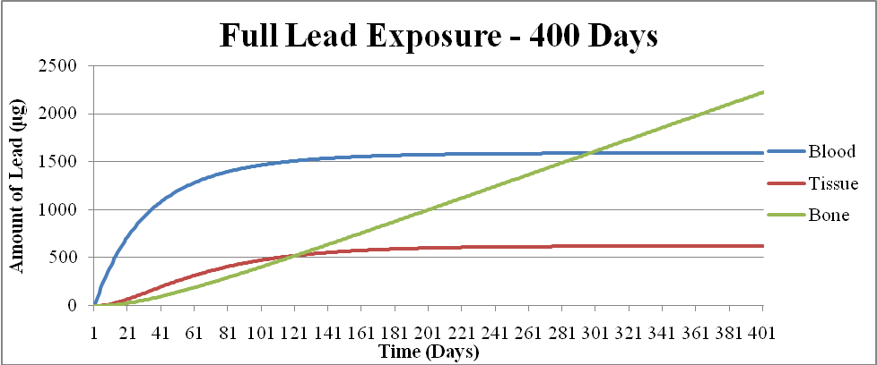

Figure 2. Full Lead Exposure Over 400 Days
Figure 2 shows the graph of how much lead gets into the blood, tissue, and bones over the course of 400 days. The data starts with all of the compartments lead-free. The amount of lead in the blood increases rapidly at first, but begins to slow down before leveling off at about 1600 μg. The amount of lead in the tissue follows a similar trend; however, not as much lead gets into the tissue. After about 200 days, the amount of lead begins to level off at just over 600 μg. The amount of lead in the bones follows a drastically different trend. The amount of lead never levels off, and it looks like it may continue to increase over time. This is perhaps due to the fact that more lead is entering the bones than leaving (see Figure 1).
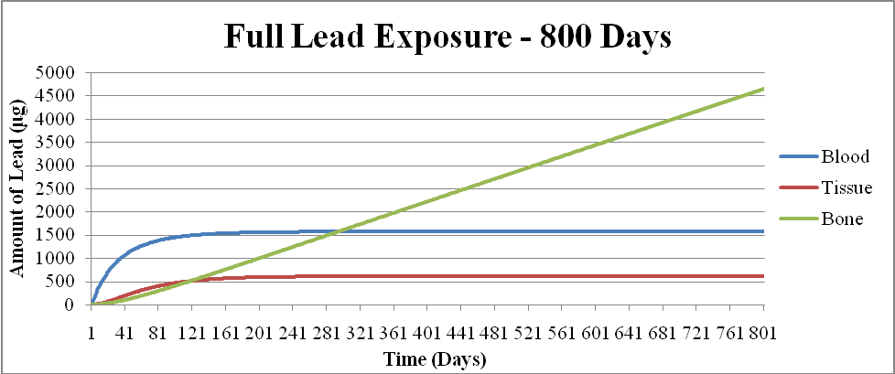

Figure 3. Full Lead Exposure Over 800 Days
To get a better look at how much lead remained in the body over time, 400 days were added to the graph (as shown in Figure 3). The amounts of lead in the blood and tissue were still leveled off at their respective quantities. However, the amount of lead in the bones did not show any improvement. That is, the amount of lead in the bones did not show any sign of decreasing at all. By the time 800 days had passed, there would be over 4500 μg of lead in the bones.
Obviously, full lead exposure can be dangerous, especially to the bones. There are, however, different treatments that can help fight off lead and its tendency to remain in the body for long periods of time. Two different ways were analyzed. The first was to see what would happen if a person were to be placed in a completely lead-free environment after 400 days of being fully exposed to lead.
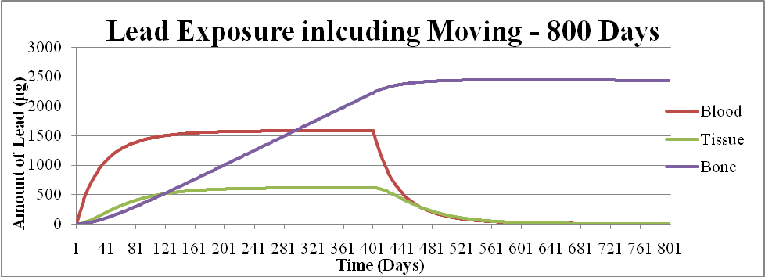

Figure 4. Lead Exposure Including the Move Over 800 Days
Figure 4 shows the effect of being moved from full lead exposure to a lead-free environment after 400 days. The equations in Figure 1 could be modified by taking the original amount of lead being added to the system out. The trends for the first 400 days look familiar (see Figures 2 and 3), but the last 400 days show a lot of improvement. The amount of lead in the blood and tissue compartments both decrease and eventually reach very low levels. Perhaps being exposed to lead kept it in those compartments, but after some time never affected how much stayed in them. The amount of lead in the bones stayed in the bones, but it slightly leveled off at about 2500 μg before slowly decreasing. The bones retain lead for a much longer period of time than the blood and tissue, as most of the lead that goes in the bones comes out very slowly.
The second method of getting rid of lead would be to give the person an anti-lead medication that would increase the rate at which lead could leave the skeletal system. This person would in addition be moved to a lead-free environment like the previous scenario. The equations shown in Figure 1 could be modified by again removing the amount of lead that would enter the system (49.3 μg), and by making the rate at which lead leaves the bones ten times faster (0.000035 to 0.00035).
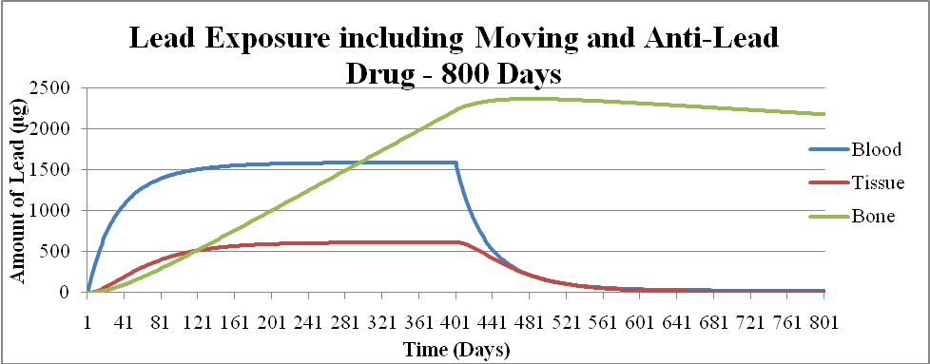

Figure 5. Lead Exposure Including Moving and Anti-Lead Drug Over 800 Days
Figure 5 shows the effect of being moved from the full lead exposure and being given an anti-lead drug over the course of 800 days. Again, the first 400 days have the same pattern. Once the person is moved and given the anti-lead drug, the amount of lead in each compartment began to drop. Like when the person was moved in the previous scenario, the amount of lead in the blood and tissue compartments both began to drop immediately and both decrease to very low levels. The amount of lead in the bones is also more promising after the drug was introduced into the system. Instead of levelling off, it began to decrease right away, at a much faster rate than before. It is still much slower than the rate of lead leaving the blood and tissue, but it would be almost all out of the system much quicker than before, when no drug was administered.
In communities around where we live, specifically the Saint Clair Shores and Eastpointe areas, lead is rarely a large problem, but in some places, lead ravages the local inhabitants ("Healthy Homes and Lead Poisoning Prevention"). The data presented by the Michigan Department of Community Health (MDCH) shows that the greatest number, namely about half, of lead poisoning cases in Michigan are filed by Detroit locals. This fact does not go unsupported either, because a distribution map (Figure 6 below) of possible sources of lead poisoning in the Detroit area presented by the Association of Health Care Journalists (AHCJ) shows that almost every school in Detroit is centered around a potentially dangerous source of lead (Dam).


Figure 6. Detroit School Distribution in Respect to Lead Sources
Figure 6 above shows a map depicting the schools in Detroit, and their respective lead exposure level. The black dots represent the schools, the blue areas represent lower lead levels, the red areas represent higher lead levels, and the white areas represent average lead levels. Again, most of the schools are sadly based in an area where the level of lead exposure is potentially dangerous (Dam).
So, it's no wonder why the Detroit area struggles so much with lead exposure. One such unfortunate case of lead exposure in Detroit was demonstrated by the Cureton family. Reggie, Jeanine and Reginald Cureton's son, was diagnosed with a dangerous level of lead poisoning after years of eating lead paint chips. Moreover, their second son, Maurice, was also diagnosed with lead poisoning. The culprit in this case, and probably a second culprit in Reggie's case, was lead dust imbedded in the carpet that was in their home. The inhalation of this dust caused the direct exposure that now troubles the children. Though, the parents haven't given up. Jeanine and Reginald have researched ways to counteract the effects of lead exposure, from brain stimulation to regular deep cleaning of the home. So what? This case brings two very important things to the mix: 1) It brings awareness to how easily lead exposure can occur and 2) It brings hope, and possible solutions to those families like the Cureton's that struggle with lead poisoning.
Contrary to the above case, the distribution maps of lead exposure presented by the MDCH shows that the Saint Clair Shores and Eastpointe areas (among others) show minimal levels of lead exposure, even though these areas are so close to the Detroit metropolitan area. So, we can conclude that our areas are primarily safe, but it is unfortunate to know that other areas struggle so much with lead exposure on top of various other problems. In light of all of this, it is very important to let everyone in our community know about the dangers of being exposed to lead, and what can be done to minimize lead exposure.
All in all, lead poisoning can be a very serious problem, unless you are careful enough not to expose yourself to it. The data shows that lead can easily be introduced into the compartments of blood, tissue, and bones, and can remain there for long periods of time. Even though lead can be very difficult to get out of the bodily system, there are many ways to prevent it from ever being introduced to the system. Such methods could be anything from drinking filtered, bottled water, to having lead paint professionally removed from a home (perhaps the lead paint could even be painted over if professional help is not feasible). While moving to lead-free environments and taking anti-lead medications are also feasible solutions, these are not always a possibility. By using our powers for good, we could raise awareness about lead exposure to the community and join people together to help accomplish some of the tasks listed above. It may not sound like much, but with cooperation and dedication, we think dangerous lead exposure may be able to be drastically reduced, or even eradicated.

Works Cited
Dam, Andrew Van. "Lead Poisoning Hurts Detroit Kids’ Academics." Web log post. Association of Health Care Journalists. N.p., 27 May 2010. Web. 24 Jan. 2015. <http://healthjournalism.org/blog/2010/05/lead-poisoning-hurts-detroit-kids-academics/>.
Finkelstein, Yoram, Morri E. Markowitz, and John F. Rosen. "Low-level Lead-induced Neurotoxicity in Children: An Update on Central Nervous System Effects." Brain Research Reviews 27.2 (1998): 168-76.ScienceDirect. Elsevier BV, 16 June 1998. Web. 24 Jan. 2015. <http://www.sciencedirect.com/science/article/pii/S0165017398000113>.
Gagnon, Steve. "The Element Lead." Jefferson Lab. N.p., 24 Jan. 2015. Web. 24 Jan. 2015. < http://education.jlab.org/itselemental/ele082.html>.
"Healthy Homes and Lead Poisoning Prevention." Michigan Department of Community Health. MDCH, 2 Feb. 2015. Web. 31 Jan. 2015. <http://www.michigan.gov/mdch/
0,4612,7-132-2942_4911_4913---,00.html>.
Lam, Tina, and Kristi Tanner-White. "High Lead Levels Hurt Learning for DPS Kids." Detroit Free Press. N.p., 16 May 2010. Web. 24 Jan. 2015. <http://www.freep.com/article/20100516/NEWS01/5160413/
High-lead-levels-hurt- learning-for-DPS-kids>.
"Lead Fact Sheet." Stanford University. Environmental Health and Safety Department, 25 Jan. 2015. Web. 25 Jan. 2015.<https://web.stanford.edu/dept/EHS/prod/general/
asbestoslead/leadfactsheet.html>.
"Lead Poisoning." MedlinePlus. Ed. Eric Perez. U.S. National Library of Medicine, 12 Jan. 2015. Web. 24 Jan. 2015.<http://www.nlm.nih.gov/medlineplus/ency/article/
002473.htm>.
Needleman, Herbert L., and Constantine A. Gatsonis. "Low-Level Lead Exposure and the IQ of Children." The Journal of the American Medical Association 263.5 (1990): 673- 78. JAMA Network. Web. 25 Jan. 2015.<http://jama.jamanetwork.com/
article.aspx?articleid=380503>.
Radošević, Zdenko, Marko Šarić, Tihomil Beritić, and Jelica Knežević. "The Kidney in Lead Poisoning." British Journal of Industrial Medicine 18.3 (1961): 222-30. The National Center for Biotechnology Information. U.S. National Library of Medicine. Web. 25 Jan. 2015. <http://www.ncbi.nlm.nih.gov/pmc/articles/PMC1038152/>.
"Toxic Substances Portal - Lead." Agency for Toxic Substances and Disease Registry. Centers for Disease Control and Prevention, 21 Jan. 2015. Web. 25 Jan. 2015. <http://www.atsdr.cdc.gov/PHS/PHS.asp?id=92&tid=22>.

