Brendan Nowakowski
Mrs. Tallman
AP Calculus
23 March 2015
Riemann Sums
Before the Fundamental Theorem of Calculus became a mathematical milestone, there had to have been ways to approximate the area underneath a function, be it a line or a curve. Three different, yet similar approximation techniques were introduced: Riemann sums, the trapezoid rule, and Simpson’s rule. All of these techniques serve the same purpose, which is finding the approximate area under a function, given the function’s values at particular values of x. None of these will give an exact area, because there will always be over- and under-approximation. However, these techniques are the best ways to find the area under a curve without knowing the function itself.
Riemann sums give a way to approximate $\int_{a}^{b}{f\left(x\right) dx}$ by computing the areas of rectangles that are bounded by the graph, and taking the sum of those areas. The equation below gives the formal definition of the Riemann sum:
$$\int_{a}^{b}{f\left(x\right) dx}=\sum_{i=0}^{n}{f\left(x_{i}\right)}\left(∆x\right)$$
In the equation, Riemann sums take the sum of all terms of term number $i$ where the height of each rectangle is $f(x_{i})$ and the width is the interval $∆x$. $n$ represents the number of intervals used to find the definite integral. Essentially, taking $\lim_{∆x→0}{(\sum_{i=0}^{n}{f\left(x_{i}\right)}\left(∆x\right))}$ would give the exact area under the curve, as the rectangles would be infinitely skinny.
The best way to get a good approximation of the area under a curve using Riemann sums would be to increase the number of intervals.
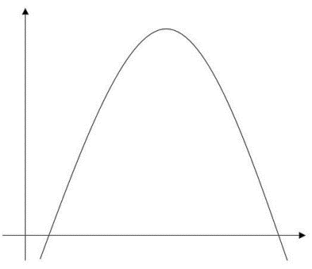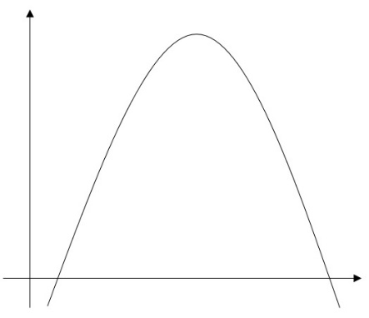
Figure 1. Increase the number of intervals
Figure 1 shows a couple of examples of approximations of area with Riemann sums using a different number of intervals each time. The first graph has one rectangle, and does not do a good job at approximating the area. The second graph has three intervals, making a clearer approximation. However, it is the third graph, with nine intervals, that best fits the area under the curve. As the number of rectangles approaches infinity, the area under the curve gets more and more defined.
There are many different types of Riemann sums. The rectangles constructed on the graph can touch the graph at either corner of the rectangle, at the midpoint of the rectangle, or even when the rectangle’s tallest edge first or last touches the graph. To show all of these different ways to find Riemann sums, we can use them on an actual function.
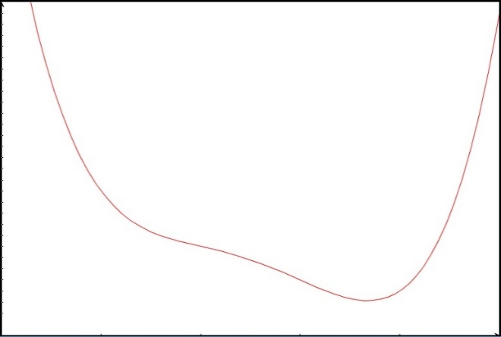
Figure 2. Graph of a quartic function
Figure 2 shows the graph of $f\left(x\right)=(x-3)^{4}+2(x-3)^{3}-4\left(x-3\right)+5$. Given this function, we can find the area underneath it using Riemann sums. For these examples, we will find the area underneath using two intervals, from $x=1$ to $x=5$. The $∆x$ value for these rectangles is 2. We will find left, right, midpoint, upper, and lower Riemann sums for the given interval.
Figure 3. Left Riemann sum
Figure 3 shows a left Riemann sum for the given interval. The rectangles’ heights are equal to where the left corner of each rectangle hits the graph. So, by evaluating the function at those points, we can find the height.
$$f\left(x\right)=(x-3)^{4}+2(x-3)^{3}-4\left(x-3\right)+5$$
$$f\left(1\right)=(1-3)^{4}+2(1-3)^{3}-4\left(1-3\right)+5$$
$$f\left(1\right)=13$$
Figure 4. Sample calculation for height of rectangle
Figure 4 shows a sample calculation for finding the height of a rectangle. In this case, the height of the first rectangle is found. The height of the first rectangle is 13 units, and the height of the second rectangle is 5 units.
$$L_{2}=f\left(1\right)\left(2\right)+f\left(3\right)\left(2\right)=\left(13\right)\left(2\right)+\left(5\right)\left(2\right)$$
$$L_{2}=26+10=36 units^{2}$$
Figure 5. Left Riemann sum evaluation
Figure 5 shows that the left Riemann sum for this problem is 36 units².
Figure 6. Right Riemann sum
Figure 6 shows a right Riemann sum for the given interval. The rectangles’ heights are equal to where the right corner of each rectangle hits the graph. The height of the first rectangle is 5 units, and the height of the second rectangle is 29 units.
$$R_{2}=f\left(3\right)\left(2\right)+f\left(5\right)\left(2\right)=\left(5\right)\left(2\right)+\left(29\right)\left(2\right)$$
$$R_{2}=10+58=68 units^{2}$$
Figure 7. Right Riemann sum evaluation
Figure 7 shows that the right Riemann sum for this problem is 68 units². This is obviously much larger than the left Riemann sum, which gave 36 units². We can still check some more Riemann sum values.
Figure 8. Midpoint Riemann sum
Figure 8 shows a midpoint Riemann sum for the given interval. The rectangles’ heights are equal to where the midpoint of the edge of each rectangle hits the graph. The height of the first rectangle is 8 units, and the height of the second rectangle is 4 units.
$$M_{2}=f\left(2\right)\left(2\right)+f\left(4\right)\left(2\right)=\left(8\right)\left(2\right)+\left(4\right)\left(2\right)$$
$$M_{2}=16+8=24 units^{2}$$
Figure 9. Midpoint Riemann sum evaluation
Figure 9 shows that the midpoint Riemann sum for this problem is 24 units². This is even smaller than the left Riemann sum, which gave an area of 36 units².
Figure 10. Lower Riemann sum
Figure 10 shows a lower Riemann sum for the given interval. The rectangles’ heights are equal to where the upper edge of the rectangle first hits the graph, and can be found graphically by finding minimums in the given intervals. The height of the first rectangle is 5 units, and the height of the second rectangle is 3.1226 units.
$$L_{2}=f\left(3\right)\left(2\right)+f\left(3.6777\right)\left(2\right)=\left(5\right)\left(2\right)+\left(3.1226\right)\left(2\right)$$
$$L_{2}=10+6.2452=16.2452 units^{2}$$
Figure 11. Lower Riemann sum evaluation
Figure 11 shows that the lower Riemann sum for this problem is 16.2452 units². This is the lowest Riemann sum yet! We still have one more Riemann sum to evaluate…
Figure 12. Upper Riemann sum
Figure 12 shows an upper Riemann sum for the given interval. The rectangles’ heights are equal to where the upper edge of the rectangle last hits the graph, and can be found graphically by finding maximums in the given intervals. The height of the first rectangle is 13 units, and the height of the second rectangle is 29 units.
$$U_{2}=f\left(1\right)\left(2\right)+f\left(5\right)\left(2\right)=\left(13\right)\left(2\right)+\left(29\right)\left(2\right)$$
$$U_{2}=26+58=84 units^{2}$$
Figure 13. Upper Riemann sum evaluation
Figure 13 shows that the upper Riemann sum for this problem is 84 units². This is the highest Riemann sum yet! Just for fun, the actual value of $\int_{1}^{5}{f\left(x\right) dx}$, from the Fundamental Theorem of Calculus, is 32.8 units². So, in this case, the left Riemann sum gave the closest answer, at 36 units².
Another good area approximation method is the trapezoid rule. The trapezoid rule allows trapezoids to be drawn on the graph, so that the angled side of the trapezoid matches up with the secant line on the graph for that given interval. Finding the area of these trapezoids and taking the sum of all of the areas would give an approximation for the area under the curve.
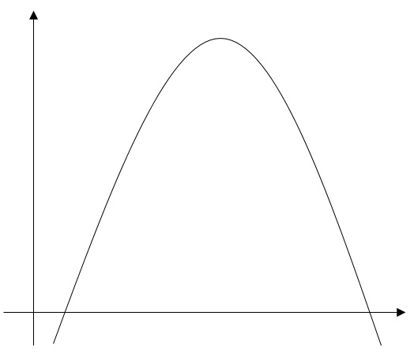
Figure 14. Trapezoid rule
Figure 14 shows a curve with the area under it made of trapezoids. As shown, the trapezoids make a very good approximation, but they under-approximate the actual area because the secant lines always lie underneath the graph. This is because of its concavity. To find the actual area under the graph, a special formula can be used. The area of a trapezoid can be given as the following:
$$Area=\frac{1}{2}({base}_{1}+{base}_{2})(height)$$
If we take this area formula and apply it to a function, we can change the base lengths to the function’s y-value, and we can change the height, or perpendicular distance between both bases, to the $∆x$ value. Because every y-value of the function except both endpoints will show up twice, and because the $∆x$ value can be factored out from every term, the area under the curve can be given by the following equation:
$$\int_{x_{0}}^{x_{n}}{f\left(x\right) dx}=\frac{1}{2}[f\left(x_{0}\right)+2f\left(x_{1}\right)+2f\left(x_{2}\right)+…+2f\left(x_{n-1}\right)+f\left(x_{n}\right)](∆x)$$
The trapezoid rule can, in instances where the number of intervals is low, be a better approximation for the area than Riemann sums because they do not under- or over-approximate it as much. In instances where the number of intervals is high, they have an equally good approximation for the area, as they both become the exact area when the number of intervals approaches infinity. Now that we know how it works, we can apply it to an actual function.
Figure 15. Trapezoid rule
Figure 15 shows the same function as used previously in the Riemann sum problems. Just by looking at this, it looks like a better approximation for the area under the function than any of the Riemann sums. However, this could easily be because the number of intervals doubled from two to four. Using the formula previously stated for the trapezoid rule, we can find the value of the area under the function.
$$T_{4}=\frac{1}{2}[f\left(1\right)+2f\left(2\right)+2f\left(3\right)+2f\left(4\right)+f(5)](1)$$
$$T_{4}=\frac{1}{2}\left[13+2\left(8\right)+2\left(5\right)+2\left(4\right)+29\right]=38 units^{2}$$
Figure 16. Trapezoid rule evaluation
Figure 16 shows the evaluation for the trapezoid rule, where the area under the curve is 38 units². The “bases” of these trapezoids are all of the values of the function evaluated at $x=1$ to $x=5$. This approximation, compared to the exact value found earlier using the Fundamental Theorem of Calculus (32.8 units²), is very close, but not as close as the left Riemann sum that we found earlier (36 units²).
One last approximation technique exists, which uses parabolas to approximate the area under a curve. This is called Simpson’s rule.
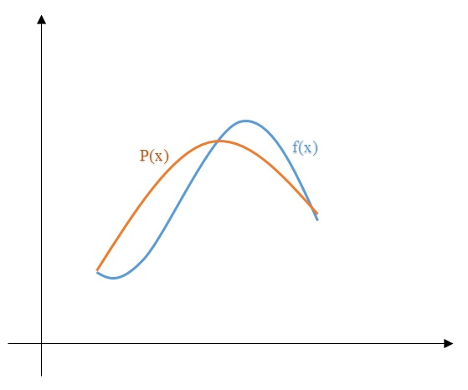
Figure 17. Simpson’s rule
Figure 17 shows an example of a parabola, $P(x)$, approximating a function, $f(x)$. Obviously, the area under this parabola will not give the exact area under the function. However, as more intervals are added, more parabolas are used to approximate the function, and they eventually fit the function exactly. Because of having curved, parabolic edges as opposed to linear edges, Simpson’s rule is the best approximation technique for area under a curve, especially for larger interval numbers.
Simpson’s rule does have a catch. Only an even number of intervals can be used. This is because in the equation for Simpson’s rule, having an additional interval would throw off the entire area. For ease of explanation, the derivation of the formula for Simpson’s rule will not be shown. The formula itself is as follows:
$$\int_{x_{0}}^{x_{n}}{f\left(x\right) dx}=\frac{∆x}{3}\left[{f(x}_{0}\right)+4f\left(x_{1}\right)+2f\left(x_{2}\right)+4f\left(x_{3}\right)+2f\left(x_{4}\right)+…+4f\left(x_{n-1}\right)+f(x_{n})]$$
Having that extra interval would make the $f\left(x_{n-1}\right)$ term be multiplied by two, which would not give an accurate result.
One important theorem about integrals is the Mean Value Theorem for integrals. This theorem states that if a given function $f$ is continuous on $[a,b]$, then $∃$ (there exists) a number $c$ in $[a,b]$ such that $f\left(c\right)=\frac{1}{b-a}\int_{a}^{b}{f\left(x\right) dx}$. In other words, this function proves that a continuous function will have at least one point wherein the function evaluated at that point will equal the average value of the function.
c
b
a
Figure 18. Mean Value Theorem for integrals
Figure 18 shows an illustration of the Mean Value Theorem for integrals. In the graph, the value of the function at $x=c$ creates a rectangle with length $b-a$. The area of this rectangle is equal to the area under the curve from $x=a$ to $x=b$. The area under the curve above the rectangle matches with the empty part inside of the rectangle, which makes the two equal.
Now, we can apply this theorem to the graph that we used when finding all of the different Riemann sums! We can find a value $f(c)$ that, when multiplied by $(b-a)$, gives the exact area under the curve. Or, as seen in the definition earlier, $f\left(c\right)=\frac{1}{b-a}\int_{a}^{b}{f\left(x\right) dx}$.
For the height of the rectangle of the first interval, we need to substitute in the values in the interval. We will set $a$ equal to 1 and $b$ equal to 3. By doing this, we get the height of the rectangle by the Mean Value Theorem.

$$f\left(c\right)=\frac{1}{3-1}\int_{1}^{3}{((x-3)^{4}+2\left(x-3)^{3}-4\left(x-3\right)+5\right) dx}$$
$$f\left(c\right)=\frac{1}{2}\left(16.4\right)=8.2 units$$
Figure 19. MVT evaluation for first rectangle
Figure 19 shows the evaluation for the height of the first rectangle. By using the fundamental theorem, we can find the exact area underneath the curve from $x=1$ to $x=3$. The evaluation shows that the height of the first rectangle is 8.2 units. For the height of the rectangle of the second interval, we need to substitute in the values in the interval. We will set $a$ equal to 3 and $b$ equal to 5.
$$f\left(c\right)=\frac{1}{5-3}\int_{3}^{5}{((x-3)^{4}+2\left(x-3)^{3}-4\left(x-3\right)+5\right) dx}$$
$$f\left(c\right)=\frac{1}{2}\left(16.4\right)=8.2 units$$
Figure 20. MVT evaluation for second rectangle
Figure 20 shows the evaluation for the height of the second rectangle. By using the fundamental theorem, we can find the exact area underneath the curve from $x=3$ to $x=5$. The evaluation shows that the height of the second rectangle is also 8.2 units. This makes sense because the height of these rectangles, when multiplied by $(b-a)$, give the exact area under the curve, by the Mean Value Theorem. The value $f(c)$ is known as the average value of the function, and should be the same for the entire function, in the given interval.
f(c)=8.2
Figure 21. MVT applied to function
Figure 21 shows the average value of the function, 8.2, and how it is the height of both rectangles. The area of both of the rectangles combined would give the exact area under the curve from $x=1$ to $x=5$, which found earlier to be 32.8 units².
Now that we have gained an understanding of the topic, let’s apply these properties and rules to problems from an AP Calculus test!
The Problems
Table 1
Values for the problem
t (seconds) | 0 | 1 | 4 | 7 | 11 | 12
r’(t) (ft/sec) | 5.7 | 4.0 | 2.0 | 1.4 | 0.5 | 0.4

Table 1 shows the values for the problem. The scenario reads the following: “The volume of a spherical hot air balloon expands as the air inside the balloon is heated. The radius of the balloon, in feet, is modeled by a twice-differentiable function r of time t, where t is measured in seconds. For $0<t<12$, the graph is concave down. The table above (Table 1) gives selected values of the rate of change, $r'(t)$, of the radius of the balloon over the time interval $0≤t≤12$. The radius of the balloon is 32 feet when $t=7$. (The volume of a sphere of radius $r$ is given by $V=\frac{4}{3}πr^{3}$).”
Part (a) of the problem reads the following: “Estimate the radius of the balloon when $t=7.2$ using the tangent line approximation at $t=7$. Is your estimate greater than or less than the true value? Give a reason for your answer.” This problem requires finding a tangent line approximation at $t=7$. The problem gives us all of the values that we need: a slope, and a point from the original function. The point of reference is $(7,32)$, because the problem tells us that the radius of the balloon at $t=7$ is 32 feet. The rate of change, or slope, at $t=7$ is 1.4, as given from Table 1. Therefore, the equation of the tangent line is $r(t)=1.4t+22.2$. Plugging in 7.2 for $t$ will give us an approximation of the radius of the balloon at that time.
$$r\left(t\right)=1.4t+22.2$$
$$r\left(7.2\right)=1.4\left(7.2\right)+22.2$$
$$r\left(7.2\right)=32.28 feet$$
Figure 22. Radius at $t=7.2$
Figure 22 shows the evaluation of the radius at $t=7.2$, which is 32.28 feet. The second part of the problem asks if this radius is greater than or less than the actual value. For this, we can look at the tangent line compared to the actual function.
Figure 23. Tangent line for concave-down graph
Figure 23 shows a graph that is concave-down. This is all that we need for the second part of the problem because all concave-down graphs will behave the same when it comes to their tangent lines. We see here that the tangent line, where it does not touch the graph, is greater than the values on the graph. Therefore we can say that the approximation of the radius is greater than the true value.
Part (b) of the problem reads the following: “Find the rate of change of the volume of the balloon with respect to time when $t=7$. Indicate the units of measure.” This problem requires implicit differentiation. We were given the equation for the volume of the balloon, so if we implicitly differentiate, we could get the rate of change of volume.
$$V=\frac{4}{3}πr^{3}$$
$$\frac{dV}{dt}=4πr^{2}*\frac{dr}{dt}$$
$$\frac{dV}{dt}=4π{\left(32\right)}^{2}\left(1.4\right)$$
$$\frac{dV}{dt}=5734.4π ft^{3}/sec$$
Figure 24. Rate of change of volume
Figure 24 gives the rate of change of the volume of the balloon at $t=7$. The values for the radius and the rate of change of the radius can be plugged into the equation, as these values were given. By basic multiplication, the rate of change of the volume can be simplified down to 5734.4π ft³/sec.
Part (c) of the problem reads the following: “Use a right Riemann sum with 5 subintervals indicated by the data in the table to approximate $\int_{0}^{12}{r^{'}\left(t\right) dt}$. Using correct units, explain the meaning of $\int_{0}^{12}{r^{'}\left(t\right) dt}$ in terms of the radius of the balloon.” This should be pretty straightforward. The only difference between this problem and the one that we did earlier is that the subintervals are not equal.
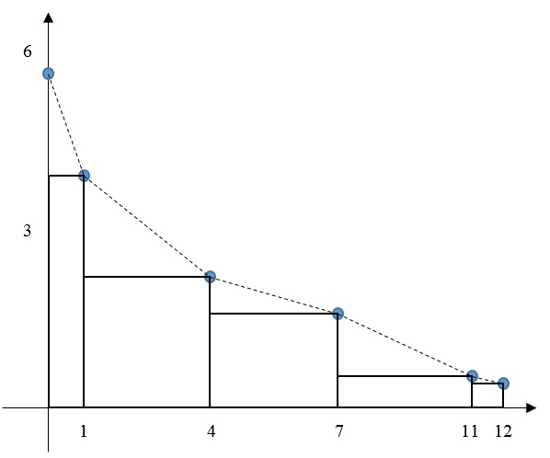
Figure 25. Graph for values from Table 1
Figure 25 shows a graph of the values from Table 1, with the appropriate rectangles drawn in for the right Riemann sum. The points are also connected with dotted lines – this will help in the explanation of a later problem. To find the right Riemann sum, we just have to plug in all of the values from the table into the formulas.
$$R_{5}=f\left(1\right)∆x+f\left(4\right)∆x+f\left(7\right)∆x+f\left(11\right)∆x+f\left(12\right)∆x$$
$$R_{5}=4\left(1\right)+2\left(3\right)+1.4\left(3\right)+0.5\left(4\right)+0.4\left(1\right)$$
$$R_{5}=4.0+6.0+4.2+2.0+0.4=16.6 feet$$
Figure 26. Evaluation of right Riemann sum
Figure 26 shows the evaluation of the right Riemann sum that approximates $\int_{0}^{12}{r^{'}\left(t\right) dt}$. This tells us the radius of the balloon after growing for 12 seconds at a rate of change $r'(t)$. The radius, in this case, is 16.6 feet.
Part (d) of the problem reads the following: “Is your approximation in part (c) greater than or less than $\int_{0}^{12}{r^{'}\left(t\right) dt}$? Give a reason.” The answer to this is simple to figure out: just look at the graph, and if the rectangles go above the graph, then the approximation is greater, and if the rectangles stay below the graph, then the approximation is smaller. In this case, if you look back at Figure 25, all of the rectangles stay below the graph, meaning that there is a lot of extra, empty space. So, the approximation is actually less than the true radius. That is the conclusion of the problem.

