Brendan Nowakowski

Mrs. Tallman

AP Calculus

23 February 2015

Solids of Revolution

Area and volume are two essential topics that are taught to students in school, usually as an introduction before high school, and more in-depth in a geometry class. The concepts of area and volume are basic, so they can be applied to many different shapes and figures in many different ways. Take the area of a rectangle, for example. The area of the rectangle would be the length of one side times the length of the other. Then, in a third dimension, a height is constructed, creating a rectangular prism. Taking the area of the original rectangle, the base, and multiplying it by the height of this prism would give the volume of the object. These basic rules are used time and time again throughout geometry when, for example, finding the area of a hexagon or finding the volume of a cone. With calculus, using the same concepts that were taught when area and volume were introduced, the area under and between functions can be computed, and the volume of the solid formed by taking that area and either rotating it around some axis or using it as a base for cross-sections can also be found.

Functions, when first introduced, seemed elementary, as they were usually a linear function. As algebra progressed, these functions became more complex, introducing curves and concavity.

4

3

2

1

2

1

Figure 1. Graph of y = x2

Figure 1, for example, shows a curve. For now, assume that the curve is the graph of $y= x^{2}$. The first problem is finding the area *under* the curve, from $x=0$ to $x=2$. Initially, counting squares is a good way to estimate the area under a curve. However, this graph does not give squares to count, so another method must be used. The only method that will give the exact area under a curve is using calculus.

The area under any curve can be found by using a definite integral:

$$Area=\int_{a}^{b}{f\left(x\right)dx}$$

This integral would give the area under the curve $f(x)$ from $x=a$ to $x=b$. The explanation behind this notation is fairly simple. In the same way that the area of a rectangle is the product of its length and width, the area under a curve is the product of its x and y values. In fact, the definite integral is essentially just taking the graph and cutting it up into infinitely skinny vertical rectangles, and summing up their areas.

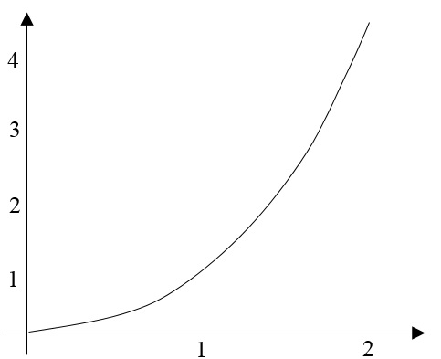

b

a

dy

dx

Figure 2. Area under a curve

Figure 2 shows the same graph as Figure 1. Now included in this graph are two vertical lines, one at $x=a$, and the other at $x=b$. Let’s call this the change in x, or $dx$. If the graph was horizontal at the top of this new region, then the area of this region would simply be the product of the function evaluated at a or b and the value of $dx$; however, the function given is not a constant, but a curve. So, with every dx comes a change in y, $dy$, which is also shown above. The only way to find the area of this region by using the formula for the area of a rectangle is by having a $dy$ of zero. This means that there would have to be no change in the function’s value. For that to be true, the value of $dx$ would also have to be zero. Calculus allows for this to work. Evaluating the $\lim_{dx→0}{f\left(x\right)dx}$ would give the area of the region, where $f(x)$ would act as the “length” of the rectangle, and $dx$ would act as the “width” of the rectangle.

To get the total area under the curve from $x=0$ to $x=2$, we would simply add up the area of every rectangle formed by using the limit principle. Of course, this would take a very long time to do by hand, so calculus allows for it to be written in the integral form as shown below:

$$Area=\int_{0}^{2}{x^{2}dx}$$

This integral would find the area under the curve $f\left(x\right)=x^{2}$ from $x=0$ to $x=2$.

$$Area= \int_{0}^{2}{x^{2}dx}=2.\overline{6666} {units}^{2}$$

Figure 3. Area under $f\left(x\right)=x^{2}$ from $x=0$ to $x=2$

Figure 3 shows the exact area under the curve $f\left(x\right)=x^{2}$ from $x=0$ to $x=2$, which is 2.6667 units2, rounded to four decimal places.

Using the same basic principles as when finding the area under a curve, we can find the area *between* two curves.

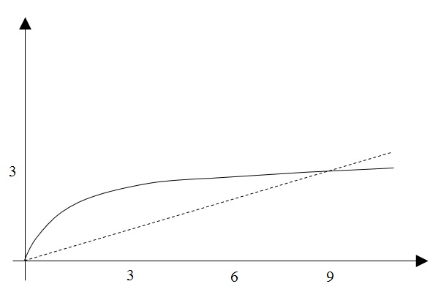

R

Figure 4. Area between two curves

Figure 4 shows an example of this. The solid curve is the graph of $y=\sqrt{x}$, and the dashed line is the graph of $y=\frac{x}{3}$. The region between the two graphs will be called R. Finding the area between two curves is actually fairly straightforward, and is similar to finding the area under a curve. In the same way that the area under a curve is cut up into very skinny rectangles, the area between these two curves can also be cut into rectangles. The only difference here is that the height of the rectangles will not be the y-value of the function, but the difference in y-values of the two given functions.



Figure 5. Finding the height of the rectangles

Figure 5, for example, shows that the height of each rectangle would be the difference between the two functions, where the height is just in the enclosed region. The width of each rectangle would still be $dx$, of course, because the measurement of the change in x did not change.

As for the setup of the integral, we first need to find the limits of integration. Zero is the obvious choice for the first limit, as they both start at the origin. As for the second, the two equations must be set equal to each other to find their intersecting point. When $y_{1}=\sqrt{x}$ and $y_{2}=\frac{x}{3}$ and they are set equal to each other, by simplification through algebra, you get the quadratic equation $0=\frac{1}{9}x^{2}-x$. Solved through the quadratic formula, the intersection point comes out to be (9,3). So, the limits of integration will be zero and nine.

The rest of the integral, the integrand, can be looked at in two different ways. Because the area between the curves is really the difference between the area under $y=\sqrt{x}$ and the area under $y=\frac{x}{3}$, the integral can be set up as follows:

$$Area=\int_{0}^{9}{\sqrt{x}}dx- \int_{0}^{9}{\frac{x}{3}}dx$$

This integral would literally give the difference of areas. When the limits of integration are the same, however, the integral can be written as a single integral, where the integrand is the difference in the functions, as shown below:

$$Area=\int_{0}^{9}{(\sqrt{x}}-\frac{x}{3}) dx$$

Solving this integral by the reverse power rule would then give the correct answer.

$$Area=\int_{0}^{9}{(\sqrt{x}}-\frac{x}{3}) dx=4.5 {units}^{2}$$

Figure 6. Area between $y=\sqrt{x}$ and $y=\frac{x}{3}$

Figure 6 shows the solution to the integral, where the area between the curves $y=\sqrt{x}$ and $y=\frac{x}{3}$ is 4.5 units2.

Just as the definite integral can compute the area under and between curves, it can also be used to find the volume of a solid that was formed by taking a function and revolving it around an axis of rotation. By doing this, circular cross sections are created within the solid. By using the same techniques of integration as before, we can find the volume of one of these cross sections, a “disk”, and add up all of the volumes from one given value to another.

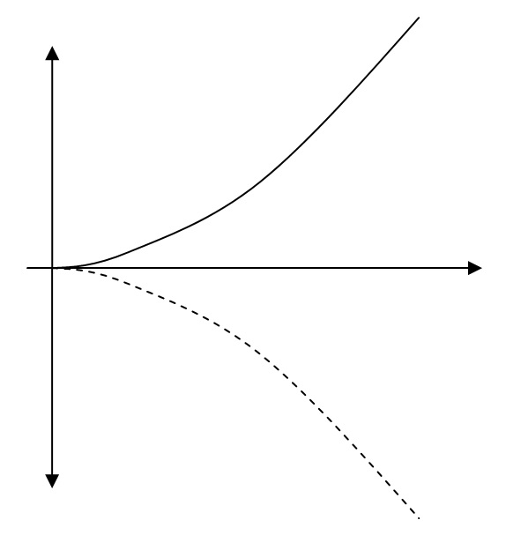

Figure 7. The graph of $y=x^{2}$, with the $dx$ cut

Figure 7 shows the graph of $y=x^{2}$, with a dotted, reflected version under the x-axis. The goal is to slice the graph into skinny rectangles, like we did before, but then revolve those around the x-axis. The $dx$“cut” was made in the graph in Figure 7, in red.

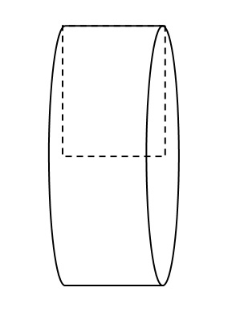

Figure 8. Cylinder from revolving rectangle around an axis

When a rectangle is revolved around one of its sides, the resulting three-dimensional object is a cylinder. This is shown in Figure 8. Now, the volume of the cylinder is the product of the area of the base and the height. These components of the cylinder can be related to the functions on the graph.



1

2

3

Figure 9. The graph of $y=x^{2}$, revolved around the x-axis

Figure 9 shows the graph of $y=x^{2}$ revloved around the x-axis. Three cross-section disks are shown, with the $dx$ cut shown in one to show that the thickness of each of these disks is just $dx$. The limits of integration for this given problem will be from $x=0$ to $x=3$. The volume of each of these disks is simply the product of the area of the base and the height, which can all be related to the function. The area of the base, which is a circle, has the equation of $A=πr^{2}$, where $r$ is the radius of the circle. Looking back at Figure 9, the radius of each of these disks is really just the height of the function, or the y value, at the given value of x. So, we can substitute the function in for the radius. By doing so, the area of the base becomes $A=π{(x^{2})}^{2}=πx^{4}$. The volume of each disk is just that equation multiplied by the thickness of the disk, which we said earlier was just $dx$. So, the volume for each disk becomes $dV=πx^{4}dx$. If we were to sum up the volume of all of these disks together, we could just integrate the volume equation to get the total volume. This integral is shown below:

$$Volume=\int_{0}^{3}{πx^{4}dx}=π\int_{0}^{3}{x^{4}dx}$$

It should be noted that the coefficient $π$ can remain outside of the integral because it will be factored back into the equation anyways. The integral can now be solved, with careful attention placed on the coefficient of $π$.

$$Volume=π\int_{0}^{3}{x^{4}dx}=48.6π units^{3}$$

Figure 10. Volume by disks solution

Figure 10 shows the solution to the integral, where the volume of the solid formed by taking the area under the curve $y=x^{2}$ from $x=0$ to $x=3$, and revolving it around the x-axis is 48.6π units3.

If the axis of rotation is not the x-axis, but the y-axis, it is a completely different story. Now, because the area between $y=x^{2}$ and the y-axis is being revolved around the y-axis, a different cut must be made. When forming disks, the cut must be made perpendicular to the axis of rotation. So, when the axis of rotation is vertical, a $dy$ cut must be made. Consequently, everything in the integral must be in terms of y.

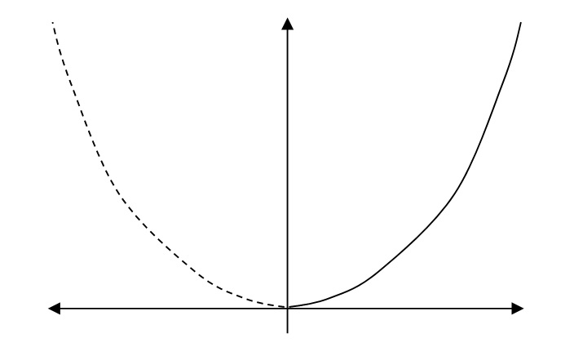

3

6

9

Figure 11. Graph of $y=x^{2}$ with a $dy$ cut

Figure 11 shows an example of a graph with a $dy$ cut. The graph of $y=x^{2}$ was reflected over the y-axis, making the dotted graph on the left. The $dy$ cut is in red. The limits of integration will be from $y=0$ to $y=9$, because everything must be in terms of y.



3

6

9

Figure 12. The graph of $y=x^{2}$, revolved around the y-axis

Once a $dy$ cut is made, the rest of the process is fairly similar to the other method, except everything must be in terms of y. If you solve the equation $y=x^{2}$ for x, then the resulting equation is $x=\sqrt{y}$. This x value will the new radius of each disk, as shown in Figure 12. The area of the circular base of each disk becomes $A=πr^{2}=π(\sqrt{y})^{2}=πy$. To get the volume, the area of the base is then multiplied by the thickness of the disk, which we know to be $dy$. The integral is as shown below:

$$Volume=π\int_{0}^{9}{y dy}$$

This integral is very straightforward due to the simplification of the y-terms through substitution into the area formula.

$$Volume=π\int_{0}^{9}{y dy}=40.5π units^{3}$$

Figure 13. Volume by disks solution, y-axis rotation

Figure 13 shows the solution of the integral, where the volume of the solid formed by taking the area between $y=x^{2}$ and the y-axis from $y=0$ to $y=9$, and revolving it around the y-axis is 40.5π units3.

A similar method to this disk method can be used to find the volume of solids that were formed by taking areas *between* curves and rotating them around some axis of rotation. This is called the “ring” method. This can be used in a number of situations, from taking an area under a curve and revolving it around an axis that is not the x-axis to taking areas between curves and revolving them around any given axis.

For example, we can take the two graphs from the area between two curves example, $y=\sqrt{x}$ and $y=\frac{x}{3}$, and revolve the area between them around any axis. For this example, we can use the line $y=-2$ as our axis.

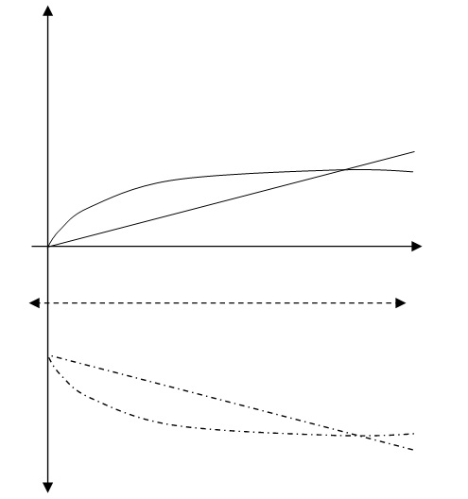

9

-2

R

Figure 14. The region R reflected over $y=-2$

Figure 14 shows the region R from Figure 4 reflected over the line $y=-2$. Also, a proper $dx$ cut was made to show that we use the same cut as shown in Figure 5.



-2

Figure 15. Rings made to show revolved area

Figure 15 shows the rings that are made after revolving the region R around the line $y=-2$. The $dx$ cut is also shown to show that the thickness of each ring is $dx$, just like the disks. The volume of each ring is really just the difference in volumes of the disk made with a radius that matches the outer part of the ring and the disk made with a radius that matches the inner part of the ring. The area of each ring can therefore be looked at as $A=π(R^{2}-r^{2})$, where $R$ is the larger radius and $r$ is the smaller radius. The volume would then be the product of the area and the thickness, which is $dx$.

The radii are found by taking the function’s value and adding the appropriate value to make up for how far the axis of rotation is from the x-axis. So, the larger radius is $R=\sqrt{x}+2$, because it is the function’s value plus an additional two units to make up for the axis of rotation. For this same reason, the smaller radius is $r=\frac{x}{3}+2$. To find the volume of the solid formed, it would simply be the following integral, with limits of integration that match the previous example:

$$Volume=π\int_{0}^{9}{((\sqrt{x}+2)^{2}-(\frac{x}{3}}+2)^{2}) dx$$

The integral can be simplified by expanding each binomial inside the integral and adding like terms; however, this does not have to be done.

$$Volume=π\int_{0}^{9}{((\sqrt{x}+2)^{2}-(\frac{x}{3}}+2)^{2}) dx=31.5π units^{3}$$

Figure 16. Solution to ring method volume problem

Figure 16 shows that the volume of the solid formed by taking the area between the curves $y=\sqrt{x}$ and $y=\frac{x}{3}$ and revolving it around the horizontal line $y=-2$ is 31.5π units3.

The ring method can also be used to find the volume of a solid that was made by revolving an area around a vertical line; however, this can be difficult as everything must be in terms of y. An easier way to do this, while still keeping everything in terms of x, is the “shell” method. This method uses infinitely skinny cylindrical shells to find the volume of a solid.

For example, we can revolve the area under the curve $y=x^{2}$ around the y-axis without using rings and putting everything in terms of y. A cylindrical shell, with a thickness of $dx$, can be used to find this volume. The volume of each shell can be found by rolling each shell out into a skinny and long rectangular prism.

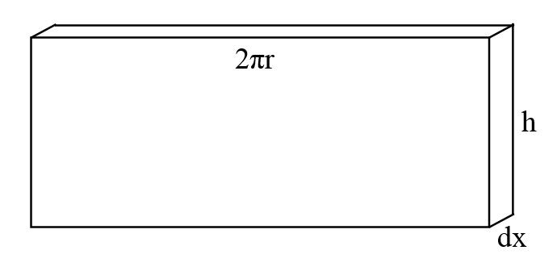

Figure 17. Cylindrical shell rolled out

Figure 17 shows a rolled out cylindrical shell. This diagram shows that the length of the prism is the same as the circumference of the shell, which is $2πr$. The width is the height, $h$, and the thickness is $dx$.



Figure 18. Shells made to show rotation around y-axis

Figure 18 shows how cylindrical shells can be made to revolve the area under $y=x^{2}$ around the y-axis. The shells are hollowed out so that only the area under the curve is revolved about the y-axis. By looking at these, we can see that some of the function’s values can be substituted into the expressions for each shell’s circumference and height. The circumference of each shell, originally given as $C=2πr$, can be rewritten as $C=2πx$, because the radius of each shell is the x-value of the function. The height, $h$, is the y-value of the function, so the height can be given as $h=x^{2}$. The integral can therefore be written as it is below, given that the limits of integration are from $x=0$ to $x=3$:

$$Volume=2π\int_{0}^{3}{\left(x\right)\left(x^{2}\right) dx}=2π\int_{0}^{3}{x^{3}dx}$$

This integral matches what would be the volume of all of the prisms, when the cylindrical shells are rolled out. The coefficient $2π$ is just written outside of the integral.

$$Volume=2π\int_{0}^{3}{x^{3}dx}=40.5π units^{3}$$

Figure 19. Solution to volume by shells problem

Figure 19 shows that the volume of the solid formed by taking the area under the curve $y=x^{2}$ and revolving it around the y-axis, by means of forming vertical, cylindrical shells, is 40.5π units3. In the previous methods of disks and rings, we saw that the cut made was always perpendicular to the axis of rotation. In the case of using shells, the cut made was parallel to the axis of rotation. That is one key difference between using disks or rings and shells.

There is one last method to find the volume of a solid based on a given graph. This would be the cross-section method, where the solid, whose base is the area under or between two curves, is cut into familiar cross-sectional shapes, like semicircles, triangles, and rectangles.

For example, we can use the area between the two curves in Figure 4, $y=\sqrt{x}$ and $y=\frac{x}{3}$, as the base, and have the solid on top of it be made of an infinite amount of isosceles right triangle cross-sections.

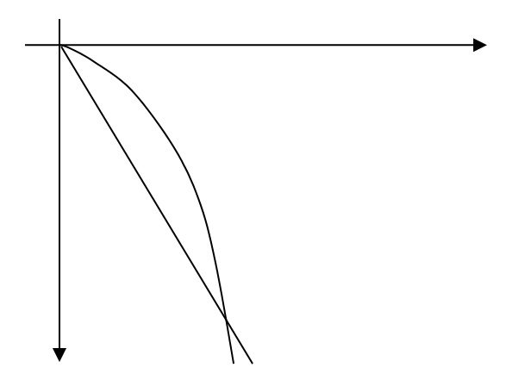

x

y

Figure 20. The region R with isosceles right triangle cross-sections

Figure 20 shows the region R with the isosceles right triangle cross-sections. We can think of these cross-sections as infinitely skinny triangular prisms with a thickness of $dx$. The volume of the prism would then be the product of the area of the “base”, which in this case is actually the right triangle side, and the “height”, which in this case is the thickness, $dx$. The area of each triangle is simply $A=\frac{1}{2}bh$, as with any triangle. However, the base and the height are the same because these are isosceles right triangles. So, the area can be given as $A=\frac{1}{2}b^{2}$, where $b$ is the difference of the one function’s value and the other. With this information in mind, the integral can be written as it is below:

$$Volume=\frac{1}{2}\int_{0}^{9}{(\sqrt{x}}-\frac{x}{3})^{2} dx$$

The coefficient of 0.5 can stay outside of the integral, just as π could when finding the volume with disks, rings, and shells.

$$Volume=\frac{1}{2}\int_{0}^{9}{(\sqrt{x}}-\frac{x}{3})^{2} dx=1.35 units^{3}$$

Figure 21. Solution for volume by cross-sections problem

Figure 21 shows that the volume of the solid formed when the region between the curves $y=\sqrt{x}$ and $y=\frac{x}{3}$ is used as the base for a solid with cross-sections of isosceles right triangles is 1.35 units3.

Calculus plays a big role when finding areas and volumes. No matter what method is used, the same basic principle behind the definite integral is used: taking a region or a solid and slicing it into infinitely skinny shapes that make it easier to find the area or volume, and then taking those values and adding them all up simultaneously. All of these methods are just special cases of finding the areas and volumes of elementary shapes and figures, like rectangles and cylinders. The definite integral just pulls it all together and makes it easy to find areas and volumes of shapes that once looked foreign to us.