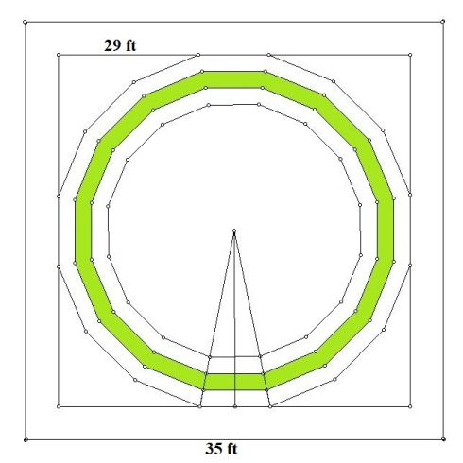
Introduction
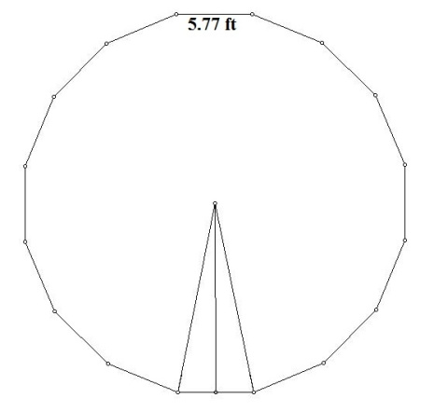
A multimillionaire has given me the job to build her a tower on a given piece of land which is a square. The plot size is 35 feet by 35 feet. However, the local rules will not allow me to build within three feet of the boundaries on all sides. The tower will have a polygonal base with a door and two windows and a roof line of a corresponding regular pyramid. The tower has to be maximized to fit perfectly inside the boundaries. A scale model was made, sized down to where one centimeter will equal one foot. The process will show how to find every side length of every part of the tower, as well as the surface area and volume of the tower.
Figure 1. Base
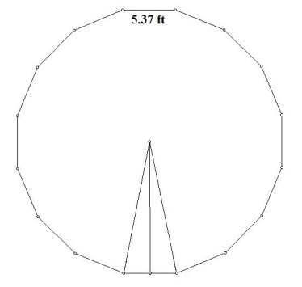
Part 2: My 16 Sided Polygon Maximized on My Plot
Figure 2. Polygon 1
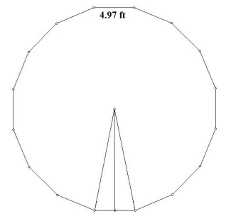
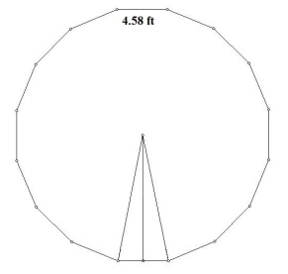
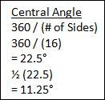
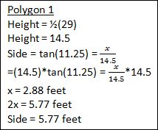
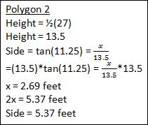
The tower will be built on a square plot of land which is 35 feet by 35 feet. However, because of the local rules, it will have to fit inside a 29 feet by 29 feet square. This is shown in Figure 1. It also shows the four polygons together. Anywhere between the first and fourth polygon is where the footings will be built underneath the tower. Figure 2 shows polygon one, which has a side length of 5.77 feet. Figure 3 shows polygon two, which has a side length of 5.37 feet. Figure 4 shows polygon three, which has a side length of 4.97 feet. Figure 5 shows polygon four, which has a side length of 4.58 feet. Figure 6 shows the formula and substitutions to find the central angle of a 16-sided polygon, which is 22.5°. Figure 7 shows the formulas and substitutions to find one side of polygon one and the height of one triangle in polygon 1 drawn from the center of the polygon to one side of the polygon. The height of the triangle in polygon one is 14.5 feet. Figure 8 shows the formulas and substitutions to find the same for polygon two. The height of the triangle in polygon two is 13.5 feet. Figure 9 shows the formulas and substitutions to find the same for polygon three. The height of the triangle in polygon three is 12.5 feet. Figure 10 shows the formulas and substitutions to find the same for polygon four. The height of the triangle in polygon four is 11.5 feet. Figure 11 shows the formulas and substitutions to find the area of polygon one, which is 669.14 square feet. Figure 12 shows the formulas and substitutions to find the area of polygon two, which is 580.03 square feet. Figure 13 shows the formulas and substitutions to find the area of polygon three, which is 497.28 square feet. Figure 14 shows the formulas and substitutions to find the area of polygon four, which is 420.90 square feet.
Figure 4. Polygon 3
Figure 3. Polygon 2
Figure 5. Polygon 4
Figure 6. Central Angle
Figure 7. Height & Side of Polygon 1
Part 3: Volume of the Footing, Floor, and Water in Aquarium
Under the tower is the 3.5 foot tall concrete footing. This will help support the tower so that is doesn’t fall down. The footing is shown in Figure 15. The inner hollow part will
Figure 8. Height & Side of Polygon 2
be 75% filled with water for the aquarium. Also, a Plexiglas floor, pictured in Figure 16, will cover polygon four and is four inches thick. It will not go above the ground, rather below it, being part of the 25% of empty space in the hollow part of the footing. Figure 17 shows the volume of the footing, which is 868.84 cubic feet. Figure 18 shows the volume of the floor, which is 140.30 cubic feet. Figure 19 shows the volume of the water in the aquarium, which is 1104.86 cubic feet. The multimillionaire wanted a cost analysis of the amount of concrete and Plexiglas
Figure 9. Height & Side of Polygon 3
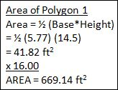
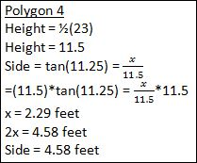
for the footing and floor, respectively. For the footing, each cubic yard is $115. One cubic yard is equal to 27 cubic feet. So, if you multiply the volume of the footing by $\frac{1}{27}$ to get the volume in cubic yards. Once it is converted to cubic yards (the volume being 32.18 cubic yards), you can multiply that by the cost of one cubic yard. When multiplied by $115, you get the
Figure 10. Height & Side of Polygon 4
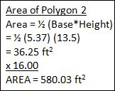
cost of the concrete which is $3700.70. For the floor, each four foot by eight foot sheet is $1100. Four times eight gives you 32, the area, in square feet, of one sheet. To find out how many sheets you need, you divide the area of polygon four by the area of one sheet. So, we need 13.15 sheets, which means we need to pay for 14 full sheets of Plexiglas. Now that we have that, we can multiply
Figure 11. Area of Polygon 1
that by the cost of one sheet, which is $1100. The final cost of the Plexiglas is $15400. If they can pay you back for giving them the leftover Plexiglas, then it will only cost $14465.
Figure 12. Area of Polygon 2
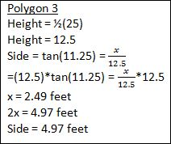
Part 4: One Lateral Face of the Outer Prism Base
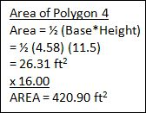
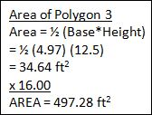
Anything with the outer prism corresponds with polygon two. To see this, look back to Figure 3. Knowing this, one side of the tower is 5.37 feet. The multimillionaire wants a door that is three feet wide and five feet tall. Figure 20 shows the door. The height of the outer prism base is two times that of one side. So, in this case, the height of the
Figure 13. Area of Polygon 3
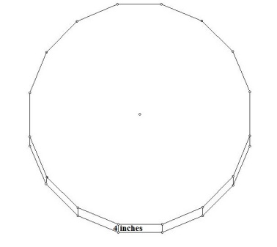
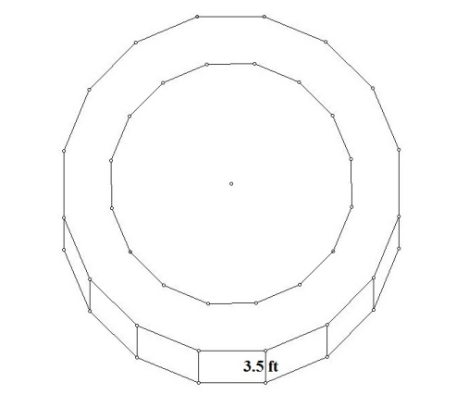
prism is 10.74 feet. Two windows, shown in Figure 21 and a half-window, which is also shown in Figure 20, on top of the door will also be included. This means that we need to subtract the area of the windows and door to find the lateral surface area. The area of the door is 15 square feet. Figure 22 shows the formulas and substitutions to find the area of the windows, including the half-window. Also shown is the total area to be subtracted from the lateral surface area of the outer prism. This is 32.90 square feet, meaning that the total area of the windows is 17.90 square feet. Figure 23 shows the formula and substitutions to find the lateral surface area of the outer prism base of the tower, which is 889.88 square feet.
Figure 14. Area of Polygon 4
Figure 15. Footing
Figure 14. Area of Polygon 4
Part 5: Volume of the Inner Base Prism
Anything with the inner prism corresponds with polygon three. To see this, look back at Figure 4. Figure 24 shows one lateral face of the inner prism. Figure 25 shows the formula and substitutions to
Figure 16. Floor
find the volume of the inner base prism, which is 5340.79 cubic feet.
Part 6: Outer Pyramid – Slant Height and Height
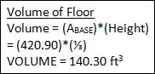
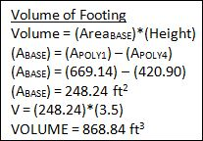
Anything with the base of the outer pyramid corresponds with polygon two. To see this, look back at Figure 3. Figure 26 shows the outer pyramid with the slant height, 21.02 feet, and the height, which is 16.11 feet. The height of the outer pyramid is three times the length of one side of the
Figure 17. Volume of Footing
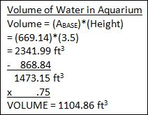
base. 5.37 times three is 16.11. Figure 27 shows the formula and substitutions to find the slant height of one lateral face of the outer pyramid, which is again 21.02 feet. Figure 28 shows the formula and substitutions to find the angle between the prism base and the
Figure 18. Volume of Floor
pyramid face, which is 50.04°.
Part 7: One Lateral Face of the Outer Pyramid
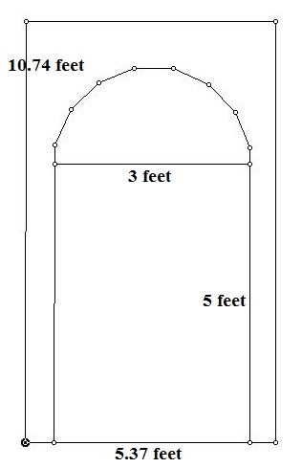
Figure 29 shows a lateral face of the outer pyramid. Figure 30 shows the formulas and substitutions to find the
Figure 19. Volume of Water
two different angle measures of the lateral face, the top angle being 14.56° and the two bottom angles both being 82.72°. Figure 31 shows the formula and substitutions to find the area of one lateral face of the outer pyramid, which is 56.44 square feet. Figure 32 shows the formula and substitutions to find the lateral surface area of the outer pyramid, which is 903.04 square feet.
Figure 20. Door Face
Part 8: Inner Pyramid – Height
Anything with the base of the inner pyramid corresponds with
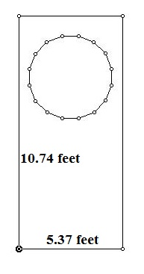
polygon three. To see this, look back to Figure 4. Figure 33 shows a picture similar to Figure 26, but the height is different. This shows the height of the inner pyramid, which is 14.91 feet. Figure 34 shows the formula and substitutions to find the volume of the inner pyramid, which is 2471.48 cubic feet.
Figure 21. Window Face
Part 9: My Tower
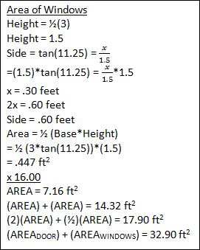
Now, for the total surface area and the total volume of the tower.
Figure 35 shows the outer tower. Figure 36 shows the formula and substitutions to find the total surface area, which is 1792.92 square feet. Figure 37 shows the formula and substitutions to find the total volume of the tower, which is 7812.27 square feet.
Figure 22. Area of Windows
Conclusion
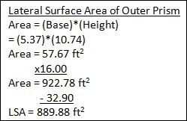
The tower model was made of out wood. The square base is
made out of foam board. I did not encounter many problems while making the tower. Some angles were cut to the nearest degree instead of the nearest hundredth of a degree. Also, because the sides were cut to the nearest tenth, not the nearest hundredth, they were getting shorter as they went around the tower, so we had to add
Figure 23. Lateral Surface Area - Prism
two strips of wood to help line it up. Other than that, the project was a lot of simple and easy math. The project clearly showed no sine of failure.

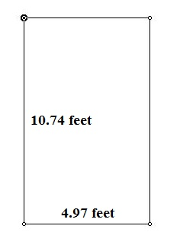
Figure 25. Volume of Prism

Figure 26. Outer Pyramid
Figure 24. Inner Prism Face

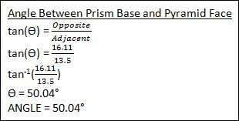
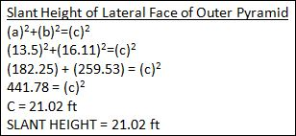

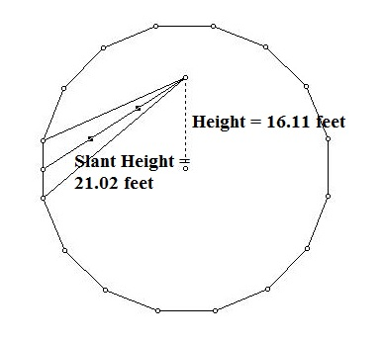
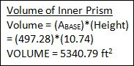
Figure 27. Slant Height
Figure 28. Angle Between Prism Base and Pyramid
Figure 27. Slant Height

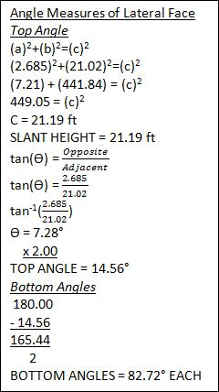
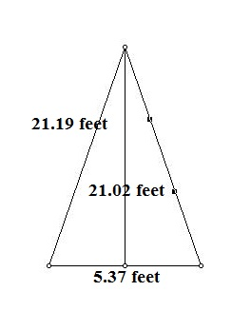
Figure 31. Area of Lateral Face of Outer Pyramid
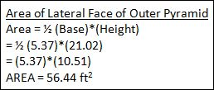
Figure 29. Lateral Face of Pyramid

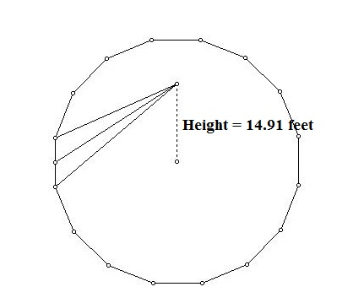
Figure 30. Angle Measures
Figure 29. Lateral Face of Pyramid

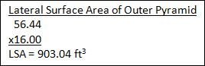
Figure 33. Inner Pyramid
Figure 32. Outer Pyramid – Lateral Surface Area
Figure 33. Inner Pyramid
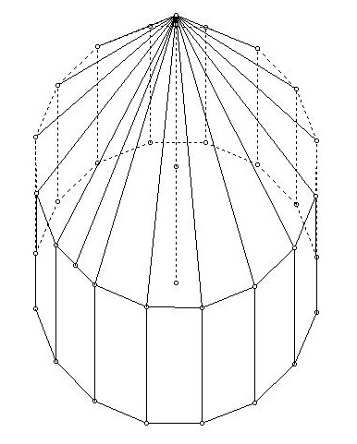
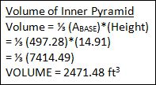

Figure 34. Volume of Inner Pyramid

Figure 35. Outer Tower

Figure 36. Lateral Surface Area of Tower
Figure 37. Volume of Tower

